**How to Build the Dementia Friendly Music Player**

**Wood Model – Use with Headphones or External Speakers**

14 March 2020, <http://DementiaMusicPlayer.org>, Ross Porter [rosswesleyporter@gmail.com](mailto:rosswesleyporter@gmail.com)

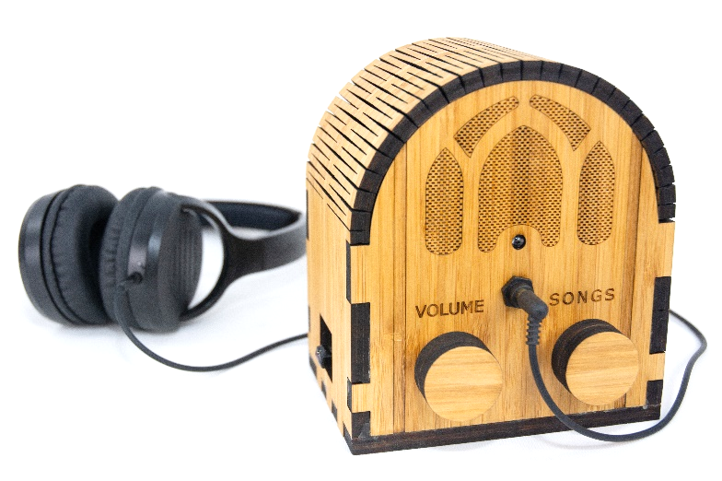  
  
I was inspired to design this by the documentary [Alive Inside](http://www.aliveinside.us/#land) which shows the profound joy felt by some with dementia when listening to their favorite music.

My Dad could no longer operate the home stereo. But he could operate this music player because it operates like a familiar two-knob radio. The vintage style fit with his old intact memories – for most people with dementia, the old memories are the strong memories.

It’s easier than you think to make one. Everything I did is open source. This document contains all the information you need. You can order the parts online, including the cut & engraved wood. It’s a good family project – kids do well with this. It’s also a project that friends would love to help you with.



|  |  |
| --- | --- |
| **Parts cost** | ~$120 + tax + shipping  (drops to ~$65 if you make 10+ at a time, see Appendix 1) |
| **Music cost** | Minimal as you should use the recipient’s existing music collection |
| **Build time** | About 3 hours once you have the parts & music,  Best if those 3 hours are spread across two days |
| **Parts source** | All parts can be mail ordered, links below |
| **Soldering?** | No |
| **Woodworking?** | No |
| **Laser cutter needed?** | No, you can mail order the pre-cut pieces for the wood case |
| **With a friend?** | Good idea, especially if your friend has the basic tools required |
| **Beverage?** | I recommend a hoppy IPA while you are assembling |

# No warranty

USE THESE DEMENTIA FRIENDLY MUSIC PLAYER PLANS AND SYSTEM AT YOUR OWN RISK. THE DEMENTIA FRIENDLY MUSIC PLAYER PLANS ARE PROVIDED AS IS WITHOUT WARRANTY OF ANY KIND EITHER EXPRESSED OR IMPLIED, INCLUDING, BUT NOT LIMITED TO, THE IMPLIED WARRANTIES OF MERCHANTABILITY AND FITNESS FOR A PARTICULAR PURPOSE. THE ENTIRE RISK AS TO THE QUALITY AND PERFORMANCE OF THE PLANS AND SYSTEM IS WITH YOU. SHOULD THE PLANS OR SYSTEM PROVE DEFECTIVE, YOU ASSUME THE COST OF ALL NECESSARY SERVICING, REPAIR OR CORRECTION. IN NO EVENT WILL ANY PARTY BE LIABLE TO YOU FOR DAMAGES, INCLUDING ANY GENERAL, SPECIAL, INCIDENTAL OR CONSEQUENTIAL DAMAGES ARISING OUT OF THE USE OR INABILITY TO USE THE PLANS OR SYSTEM.

# Acknowledgements

People were very generous with their time, and I really enjoyed the experience. This is certainly an incomplete list: Alex & Mike & others at [Ada’s](http://blog.seattletechnicalbooks.com/), the super smart staff at [Metrix](http://www.metrixcreatespace.com/), neighbor Randy, [Stephen Christopher Phillips](http://scphillips.com/), [Bob Rathbone](http://www.bobrathbone.com/), [Stephen Rusk](http://www.stephenrusk.com/), [Graham Hill](http://www.ted.com/speakers/graham_hill), support at [Ponoko](https://www.ponoko.com/), [Florian Festi](https://www.festi.info/boxes.py/index.html), and my son.

# How it works

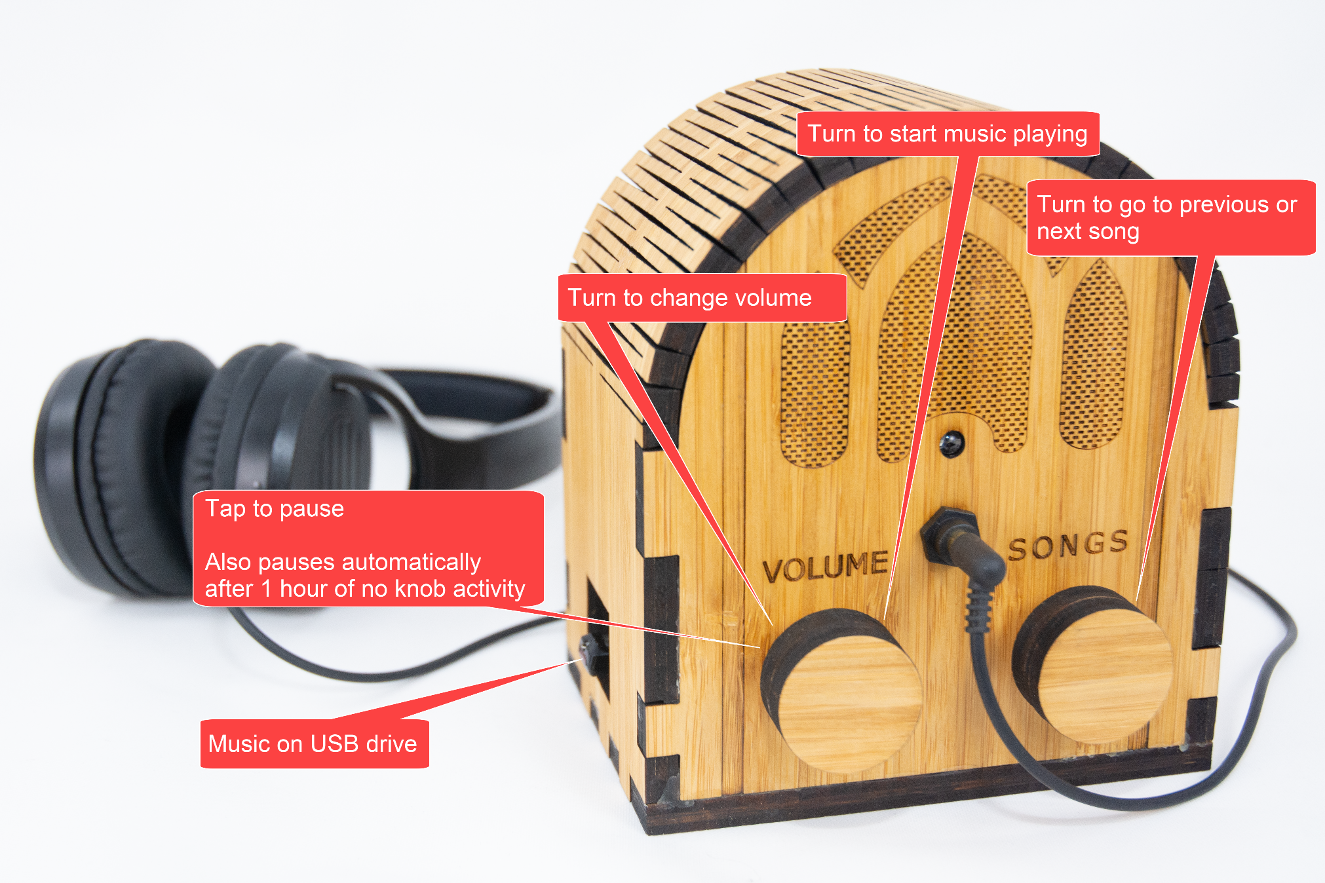

# Preview of the steps

|  |  |  |
| --- | --- | --- |
| **STEP 1: Order or make the case** | **STEP 2: Order parts** | **STEP 2: Assemble music**  Complete Beethoven Edition, Vol. 1: Symphonies |
| **STEP 4: Flash the micro SD card**  http://ecx.images-amazon.com/images/I/71sgCaQGpKL._SL1500_.jpg | **STEP 5: Add the Pi** | **STEP 6: Wire it** |
| **STEP 7: Test it** | **STEP 8: Glue it** | **STEP 9: Enjoy!** |

# STEP 1: Find a friend to do this with

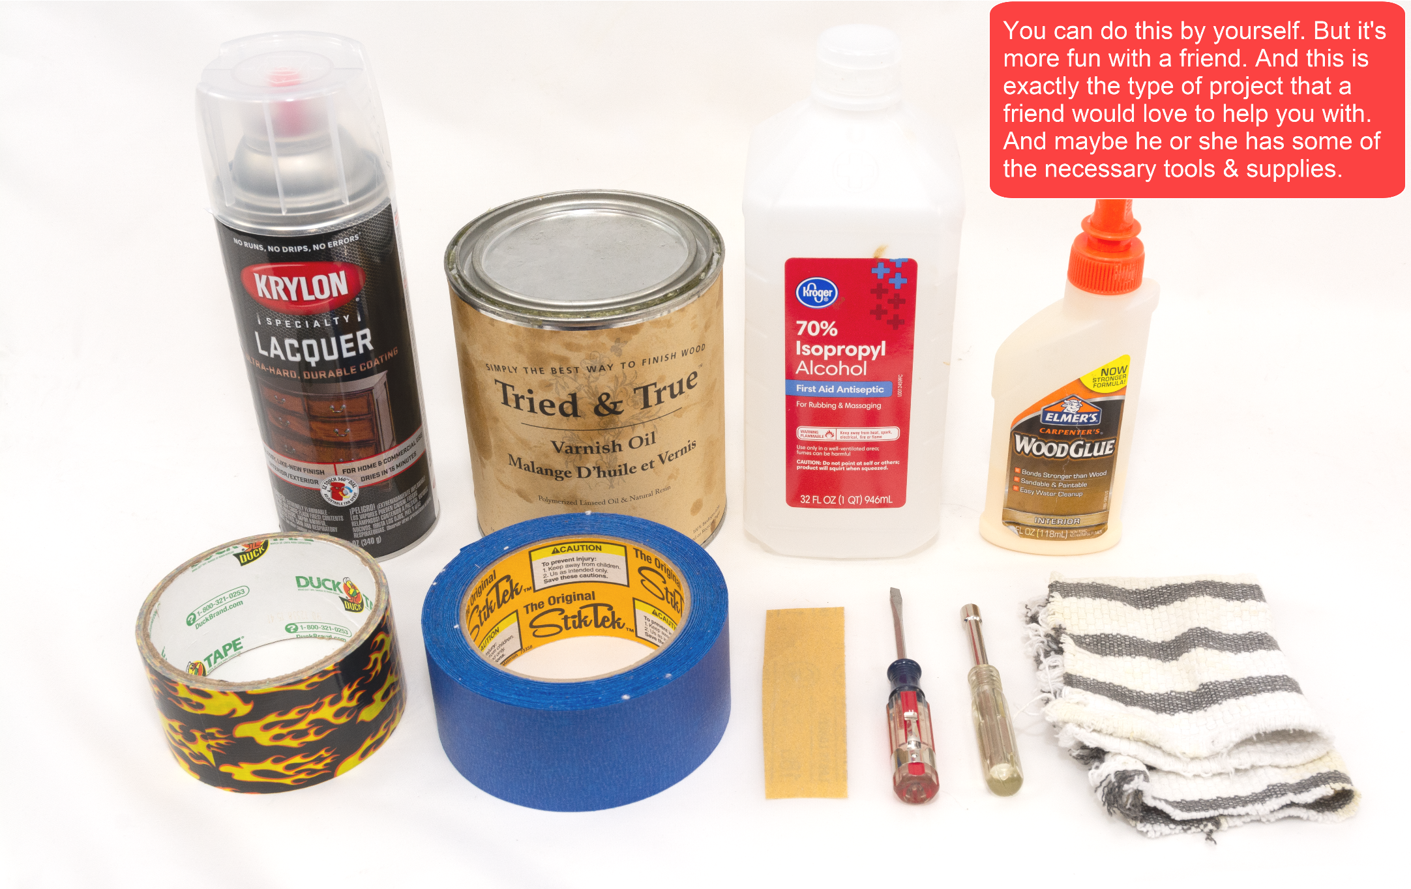

# STEP 2: Decide about making vs. ordering the case

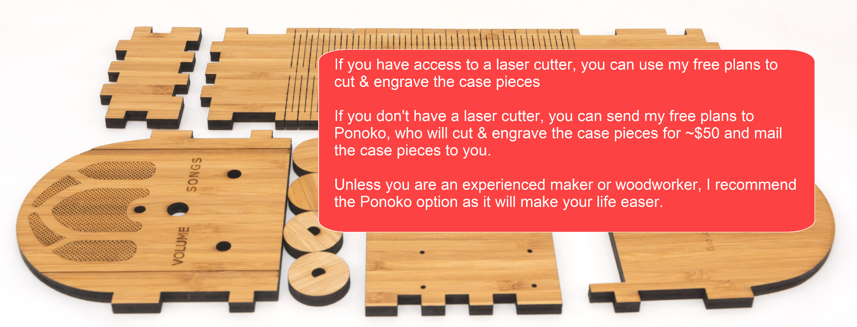

Ponoko is a company that laser cuts wood and sends you the precisely cut pieces. You don’t need to use Ponoko – you are welcome to download my case design files from [github](https://github.com/rosswesleyporter/dqmusicbox/tree/master/case/laser_cut/wood_headphones_only) and go to your local maker space and use the laser cutter there. Or buy yourself a laser cutter (if you do, will you be my friend?). In other words, Ponoko is convenient but not necessary. I have no affiliation with them, other than being a happy customer. Unless you are an experienced maker or woodworker, I recommend ordering the case – it will make the build process much easier.

# STEP 3: Get the case file

1. Go to <https://github.com/rosswesleyporter/dqmusicbox/tree/master/case/laser_cut/wood_headphones_only>

2. Get the file you want:

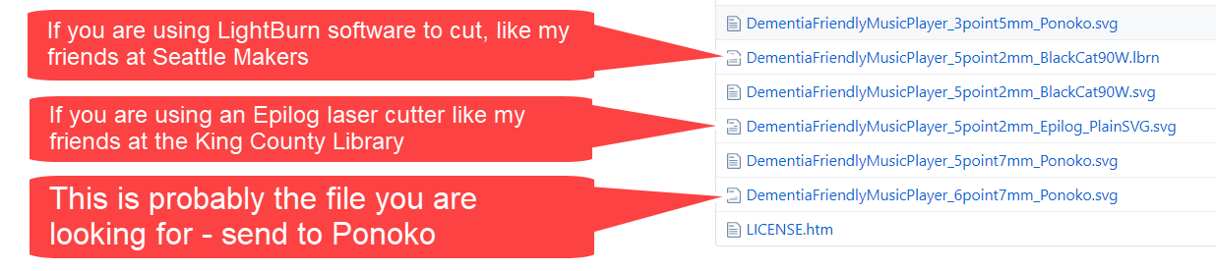

3. Right-click on the desired file, choose “Save link as…”

# STEP 4: Order the case

1. Go to <https://www.ponoko.com/>
2. Login (create an account if you haven’t already)
3. Choose “Upload your design” and upload the file that you downloaded just above  
   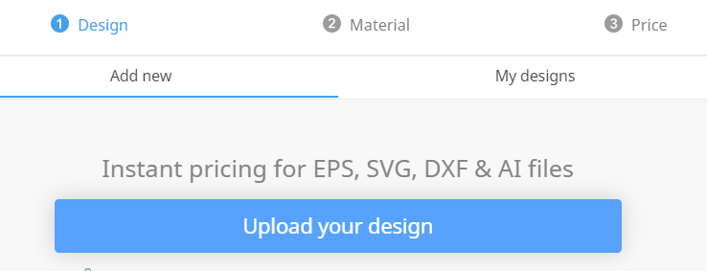
4. Set the design colors as per below:  
   
5. Choose “Confirm design size & colors”
6. Choose “Amber Bamboo Plywood”  
   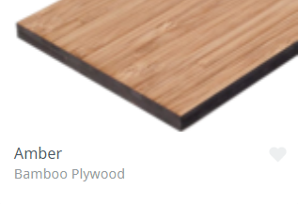
7. Choose thickness = 6.7mm and then “Confirm material”  
   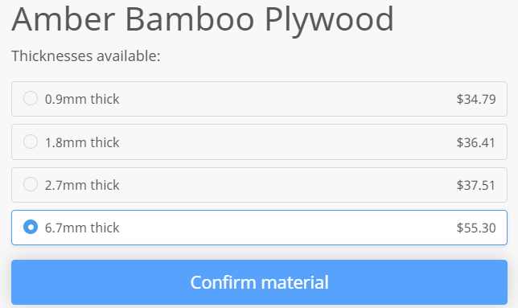
8. Make sure that everything looks as expected especially the check that the horizontal bar above SONGS is colored in  
   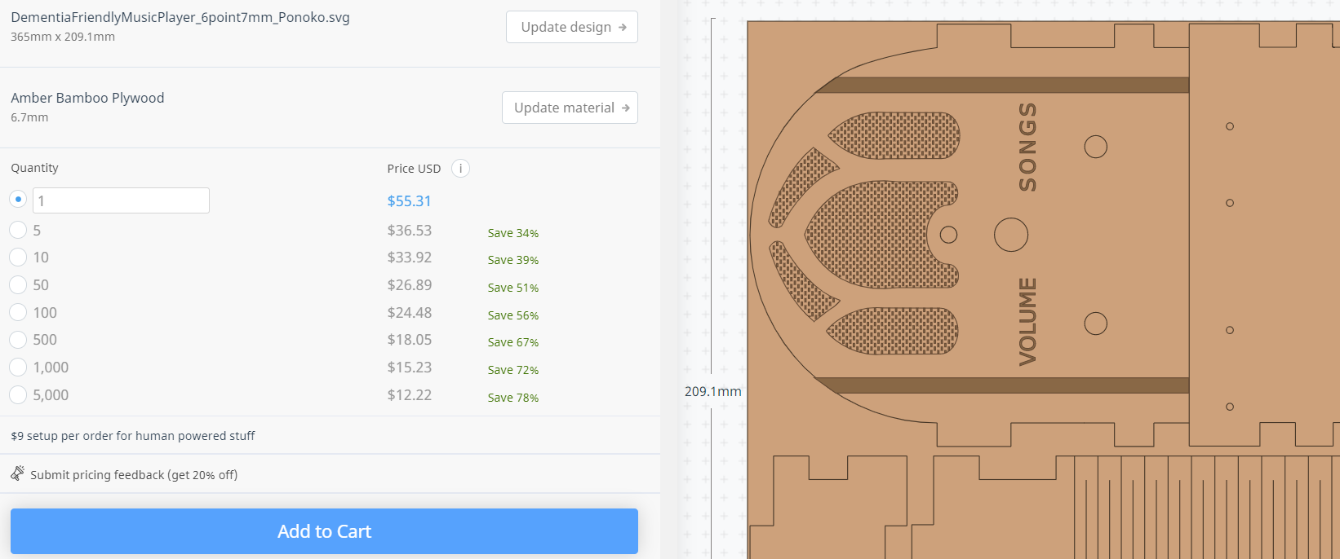
9. Click “Add to Cart”

# STEP 5: Make the case (if you didn’t order it)

If you want to make the case rather than order the case:

1. Use the file that you downloaded earlier
2. If you like, you can customize the case
3. Cut on your laser cutter or go to a makerspace and use a laser cutter there

If you are curious, this is what a design file looks like (showing the .lbrn Lightburn file):

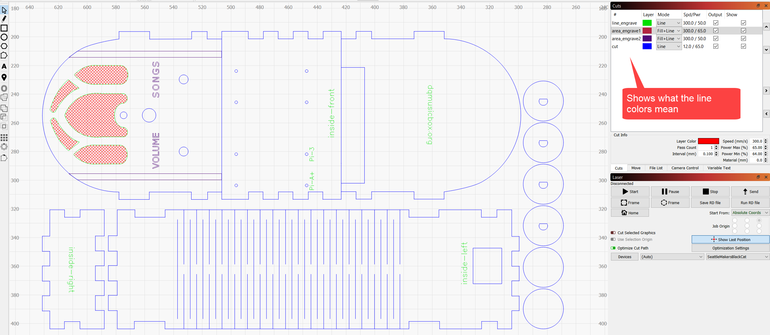

# STEP 6: Order the parts

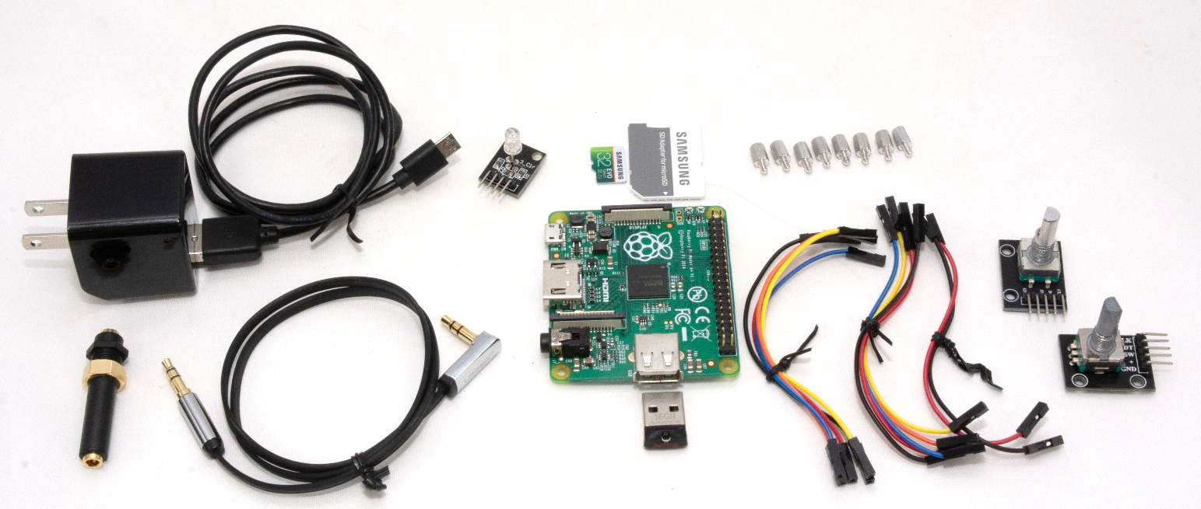

|  |  |  |  |
| --- | --- | --- | --- |
| **Item** | **Supplier** | **Cost** | **Notes & alternatives** |
| Wood case | Ponoko | $50.23 | See instructions above. |
| [Raspberry Pi 1 A+ single board computer](http://www.newark.com/raspberry-pi/raspbrry-moda-512m/silicon-manufacturer-broadcom/dp/81Y5333) | Newark | $20.00 | Also tested with a 2B, 3A+, 3B, 3B+, 4B. Do not use Pi Zero. |
| [Power supply](http://www.mcmelectronics.com/product/28-19338) | Newark | $4.99 | Or Newark [81AC2845](https://www.newark.com/raspberry-pi/t6717dv/raspberry-pi-power-supply-90-264vac/dp/81AC2845). Or order one for your region/plug. |
| [Female-female jumper wires](http://www.newark.com/adafruit/266/female-to-female-jumper-wires/dp/42X1200) | Newark | $3.95 | Or Amazon [B01L5ULRUA](https://www.amazon.com/GenBasic-Female-Solderless-Breadboard-Prototyping/dp/B01L5ULRUA/ref=sr_1_3?s=electronics&ie=UTF8&qid=1524365861&sr=1-3&keywords=female+female+jumper+wires) |
| [Panel mount 3.5mm headphone jack](http://www.newark.com/mcm/27-5937/3-5mm-inline-stereo-mount-female/dp/40T6284) | Newark | $2.69 | Or Amazon [B004JX64FE](https://www.amazon.com/3-5mm-Stereo-Feed-Thru-Panel-Mount/dp/B004JX64FE/ref=sr_1_1?s=electronics&ie=UTF8&qid=1508035643&sr=1-1&keywords=B004JX64FE) |
| [M2.5 standoffs (screws) – 8 of them](https://www.newark.com/raf-electronic-hardware/m2102-2545-al/spacer-standoff-hex-aluminium/dp/27T7975?st=M2.5%20standoff) | Newark | $4.32 | Or Amazon [B06XXV8RTR](https://www.amazon.com/eBoot-Pieces-Female-Standoff-Assortment/dp/B06XXV8RTR/ref=sr_1_1?s=electronics&ie=UTF8&qid=1508035656&sr=8-1&keywords=B06XXV8RTR) |
| [Micro SD card](https://www.amazon.com/gp/product/B079H6PDCK/ref=ox_sc_saved_title_1?smid=ATVPDKIKX0DER&psc=1) | Amazon | $4.75 | Or upgrade to Amazon [B06XWN9Q99](https://www.amazon.com/gp/product/B06XWN9Q99/ref=ox_sc_saved_title_2?smid=ATVPDKIKX0DER&psc=1). Any brand name card that is 16GB or larger will do. |
| [USB thumb drive](https://www.amazon.com/SanDisk-16GB-Cruzer-Flash-Drive/dp/B07MDXBT87/ref=sr_1_10?keywords=Cruzer+8GB&qid=1572121525&s=electronics&sr=1-10) | Amazon | $5.60 | This one is helpfully physically small, but many USB drives will work. Or Amazon [B077Y149DL](https://www.amazon.com/gp/product/B077Y149DL/ref=ox_sc_saved_title_10?smid=ATVPDKIKX0DER&psc=1). |
| [Audio cable](https://www.amazon.com/gp/product/B00LM0U8I6/ref=oh_aui_detailpage_o00_s00?ie=UTF8&psc=1) | Amazon | $5.89 | Or Amazon [B00SUIKMJ8](https://www.amazon.com/dp/B00SUIKMJ8/ref=twister_B07Q4W92M7?_encoding=UTF8&psc=1). Or find a short audio cable with a right angle bend. |
| [KY-016 indicator LED](https://www.amazon.com/KY-016-Colors-Sensor-Arduino-Starter/dp/B0786CQD5P/ref=sr_1_1?keywords=KY-016&qid=1572122200&sr=8-1) | Amazon | $6.99 | Or buy Amazon [B07KJYR8K1](https://www.amazon.com/Aokin-Sensor-Module-Arduino-Raspberry/dp/B07KJYR8K1/ref=sr_1_5?keywords=KY-016&qid=1572135296&refinements=p_85%3A2470955011&rnid=2470954011&rps=1&sr=8-5). Or search Amazon for KY-016. |
| [KY-040 rotary encoders (knobs)](https://www.amazon.com/Tegg-KY-040-Encoder-clickable-Arduino/dp/B07QL6V4WP/ref=sr_1_11?keywords=KY-040&qid=1572122001&sr=8-11) | Amazon | $7.99 | Or buy Amazon [B06XQTHDRR](https://www.amazon.com/Cylewet-Encoder-15%C3%9716-5-Arduino-CYT1062/dp/B06XQTHDRR/ref=sxts_sxwds-bia?keywords=KY-040&pd_rd_i=B06XQTHDRR&pd_rd_r=2b225097-99b4-4ec3-929d-f5a64d9b4fab&pd_rd_w=dLUS7&pd_rd_wg=HHIY2&pf_rd_p=a5491838-6a74-484e-8787-eb44c8f3b7ff&pf_rd_r=EPFB4RP3SK2JCF4ETB4C&psc=1&qid=1572129476). |
| **TOTAL** |  | **$117.40** | Prices will vary. Does not include tax, shipping. |

# STEP 7: Get headphones

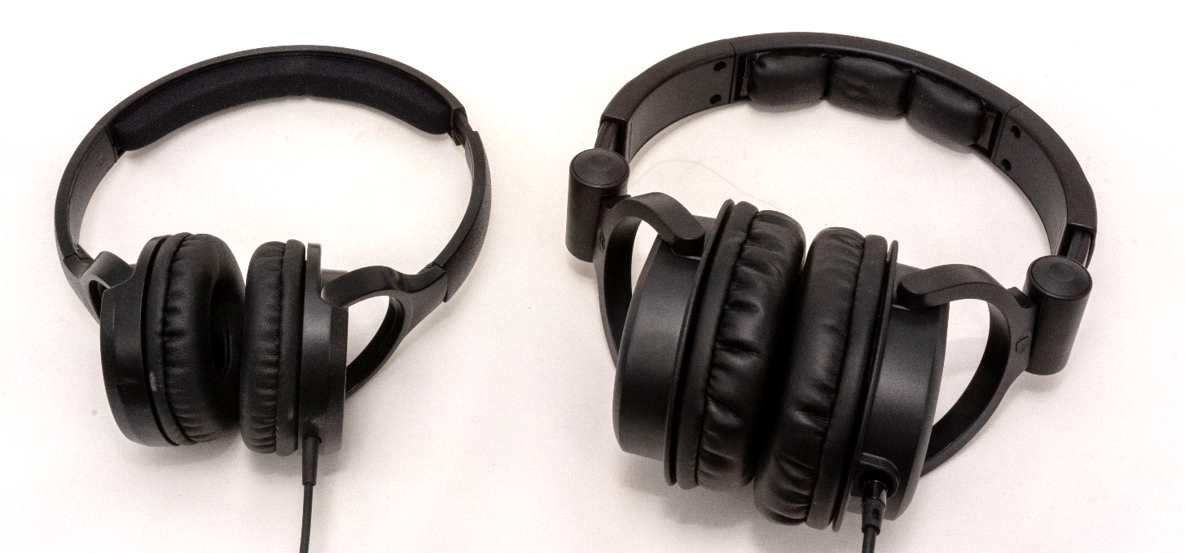

## Some headphone choices

|  |  |  |
| --- | --- | --- |
| **Item** | **Cost** | **Notes and alternatives** |
| The recipient’s existing headphone | $0.00 | The best headphones are the headphones that the recipient is already used to. |
| [Monoprice On-Ear headphones](https://www.monoprice.com/product?c_id=120&cp_id=12001&cs_id=1082302&p_id=13191&seq=1&format=2) | $10.99 | Very good sound. High sensitivity (which is important). Also available from Amazon for a slightly higher price but with Prime shipping: [B014399CWK](https://www.amazon.com/Monoprice-Lightweight-Headphones-Controls-Microphone/dp/B014399CWK/ref=sr_1_2?keywords=monoprice+on-ear&qid=1577058123&sr=8-2). |
| [Monoprice Over-the-Ear headphones](https://www.monoprice.com/product?c_id=120&cp_id=12001&cs_id=1082302&p_id=8323&seq=1&format=2) | $15.99 | Amazing sound. High sensitivity (which is important). Also available from Amazon for a slightly higher price but with Prime shipping: [B007SP2CO2](https://www.amazon.com/Monoprice-Headphones-Single-Button-Microphone-Controller/dp/B007SP2CO2/ref=sr_1_3?crid=3P248UWO7A44N&keywords=monoprice+over+ear+headphones&qid=1577058242&sprefix=Monoprice+over+ear%2Caps%2C209&sr=8-3). |
| Other |  | Look for high sensitivity headphones, as the Pi’s output is a bit weak. |

# STEP 8: Get wood finish product (optional)

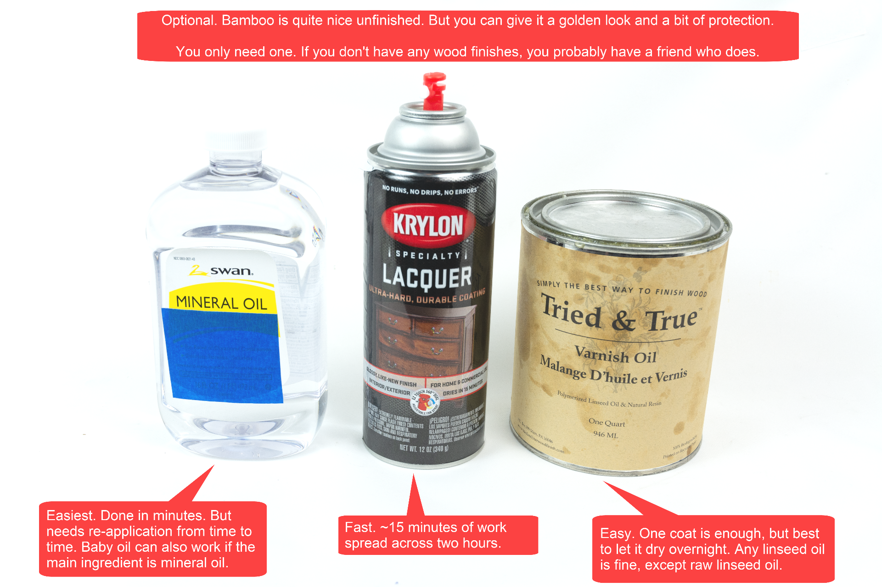

# STEP 9: Gather tools & supplies

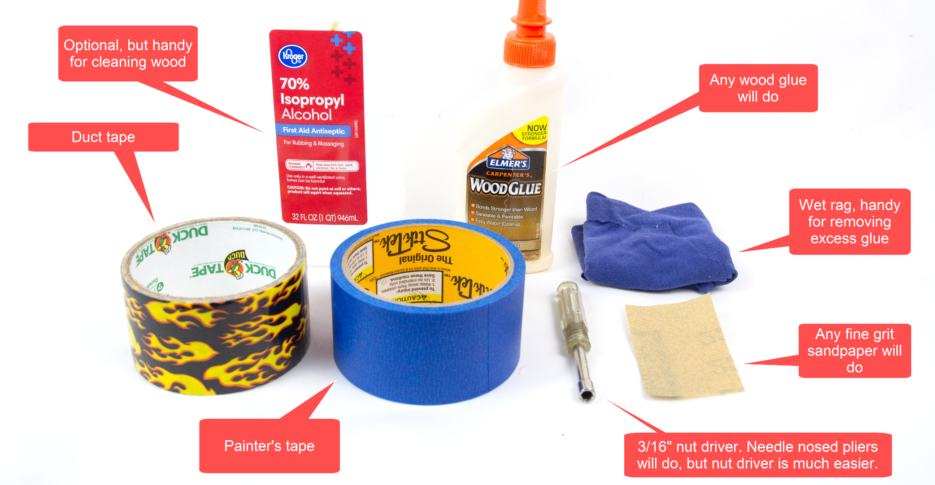

# STEP 10: Get a computer with an SD card slot

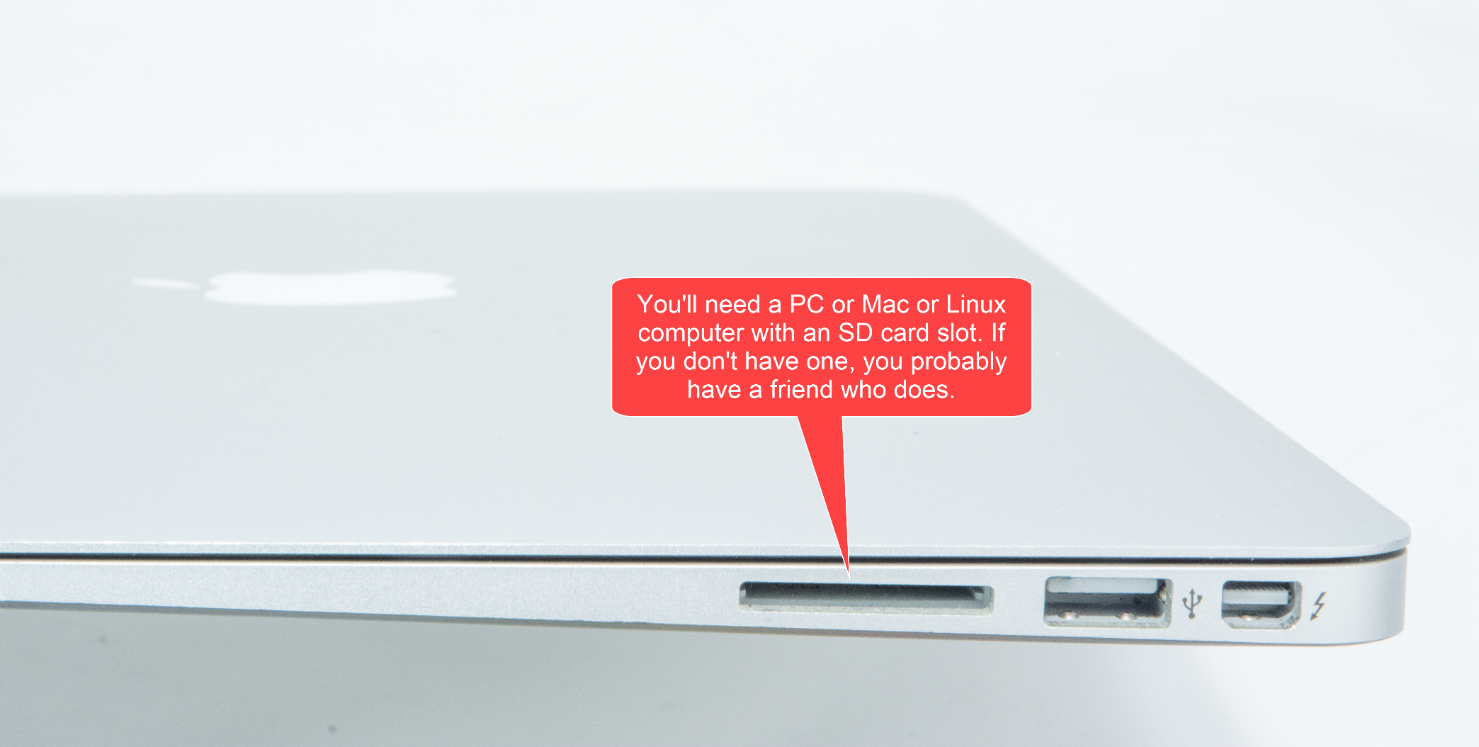

# STEP 11: Assemble the personalized collection of music

## Choosing the music – go for familiar favorites

This is the most important step. The personalized (familiar) music is the fundamental magic. You don’t need much music, perhaps 6-10 albums. But only familiar favorites. In my case, my Mom mailed me my Dad’s favorite CDs. It will take two weeks for the parts above to arrive, so you have time to do this well. Though it is easy to change the set of music later.

## Put the music on the USB memory stick

Organize the digitized music into folders on the USB memory stick, one folder per album. MP3, iTunes, and FLAC files are supported i.e. files with extensions .mp3, .m4a, .flac. In the end, you should have a set of folders that looks something like this:



# STEP 12: Copy software to the micro-SD memory card

I prepared a disk image for you. It has all the required software. Your job is to download this disk image and then write it to the micro-SD card. The steps:

1. Install [Balena Etcher](https://www.balena.io/etcher/) on your PC or Mac or Linux computer. [Win32 Disk Imager](http://sourceforge.net/projects/win32diskimager/) also works.
2. Download the [Dementia Friendly Music Player disk image](http://bit.ly/2OC3ucI).  
   
3. Confirm download – “Download anyway”  
   
4. Put the micro-SD memory card & adapter into the SD reader/writer in your computer.
5. Start Balena Etcher, instruct it to write the image file to the SD card:  
   
6. Wait for the writing to complete, ~10 minutes. This would be a good time to make a sandwich.

# STEP 13: Apply a wood finish (optional)

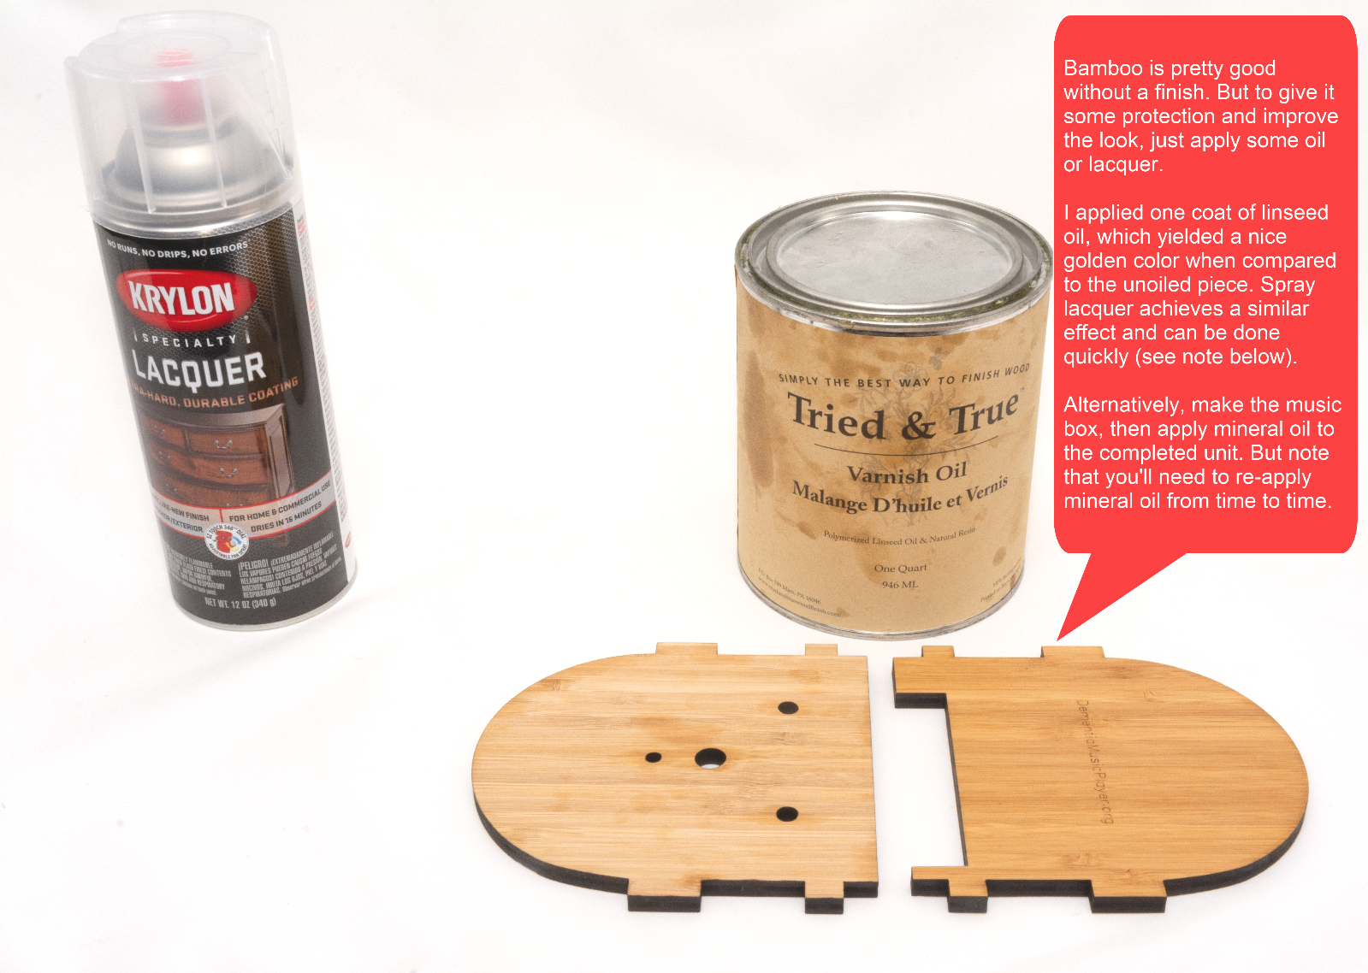

If you choose to use spray lacquer, see this [short video from Woodworking for Mere Mortals](https://www.youtube.com/watch?v=CyVPkqrNph0). The method shown is much faster than the instructions on the spray bottle. It takes about 15 minutes of work spread across two hours.

# STEP 14: Add the Pi

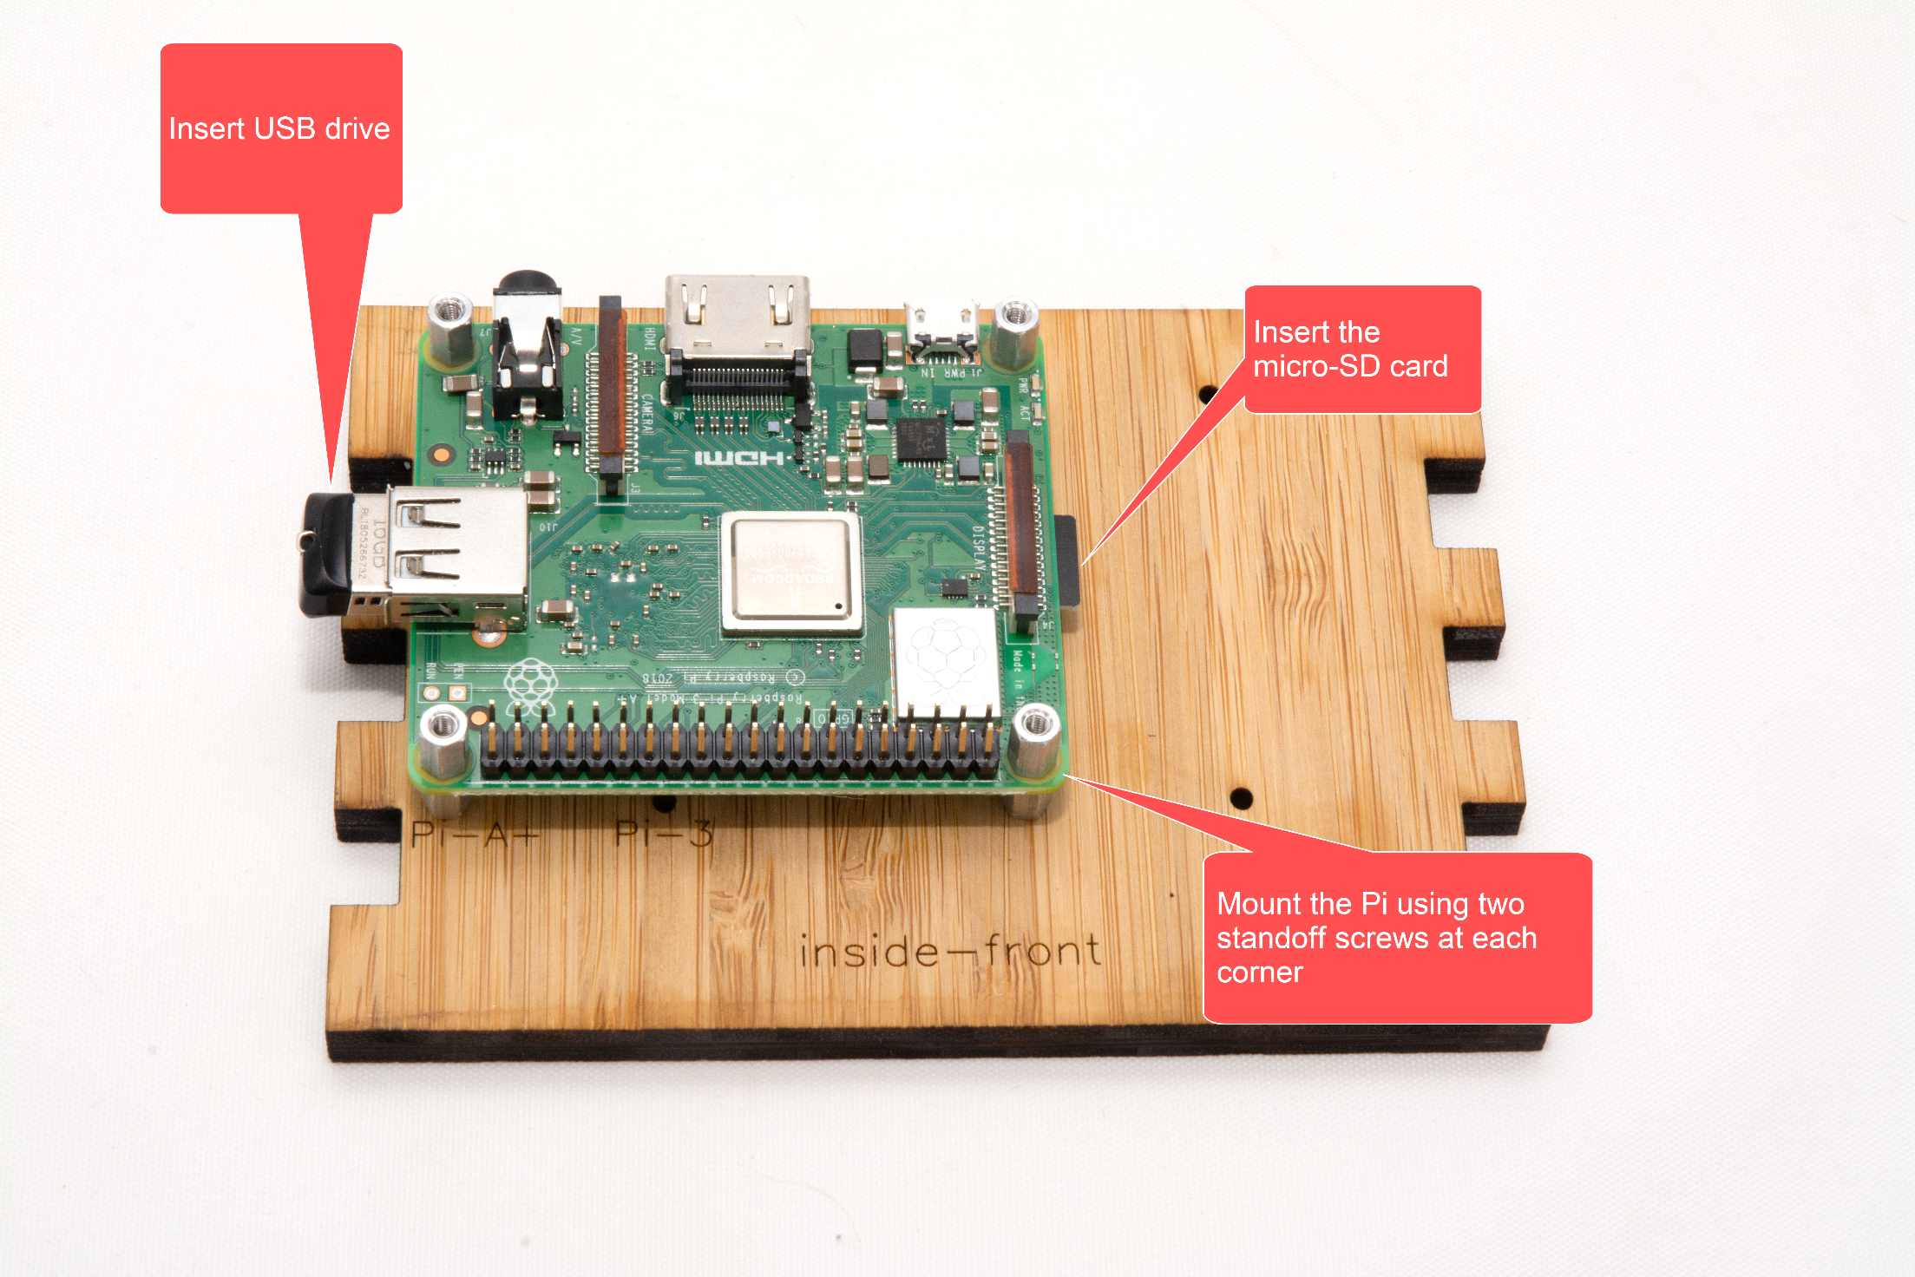

# STEP 15: Test it

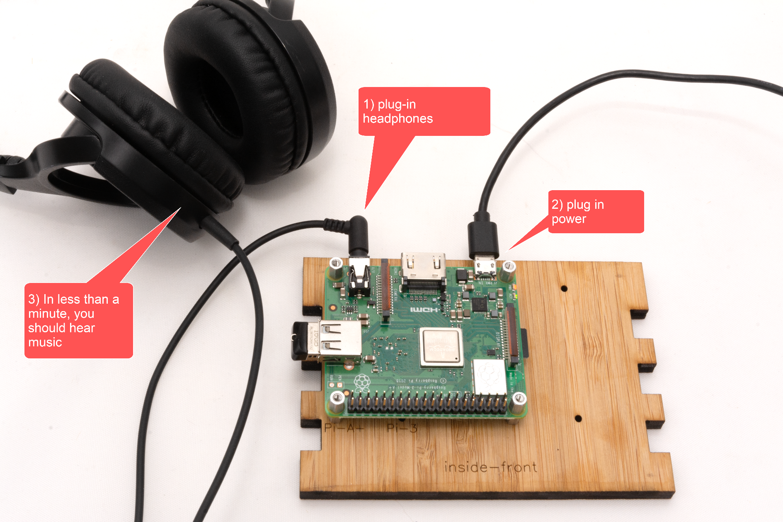

# STEP 16: Wire it

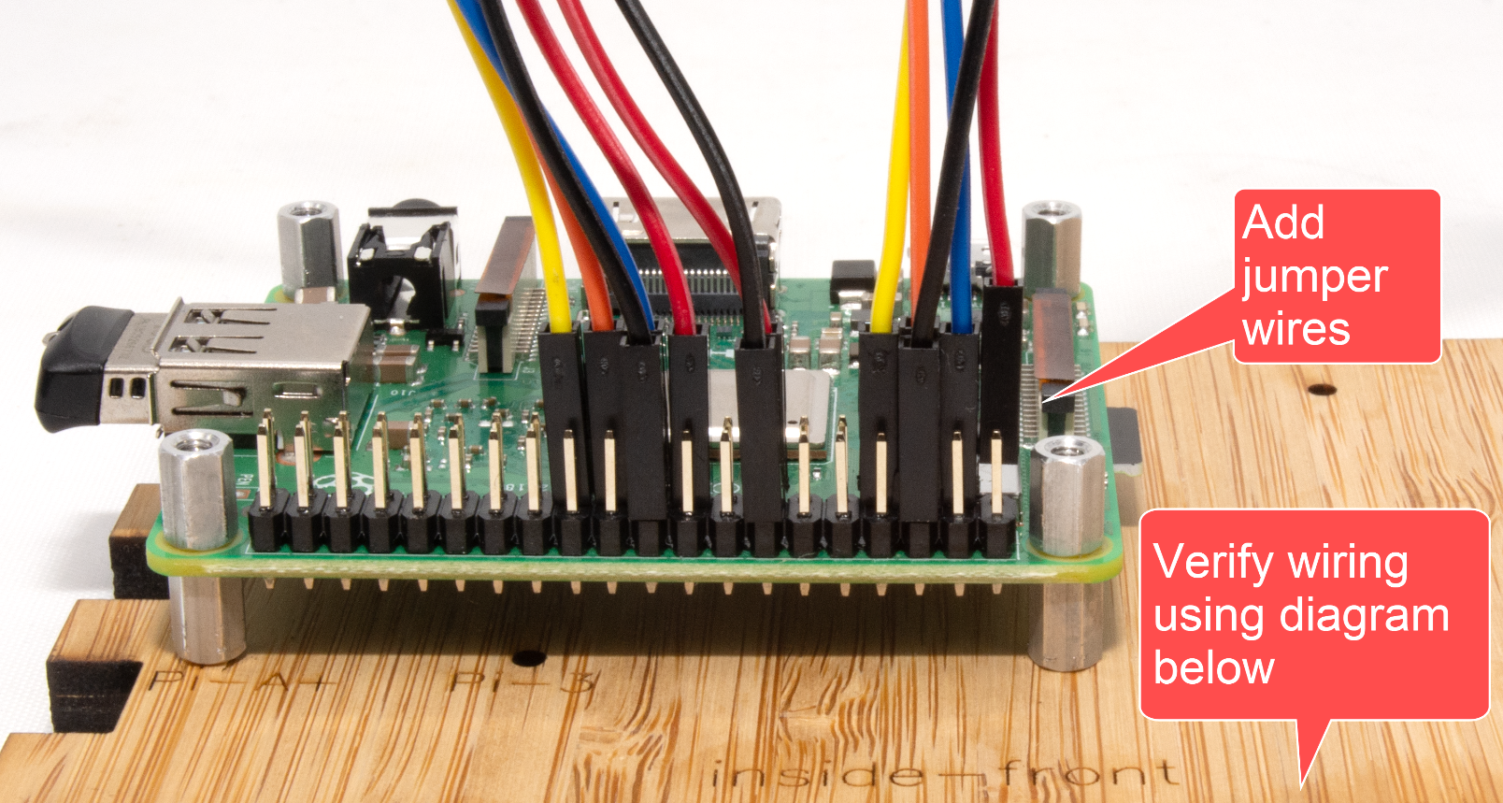

# STEP 17: Add front panel components

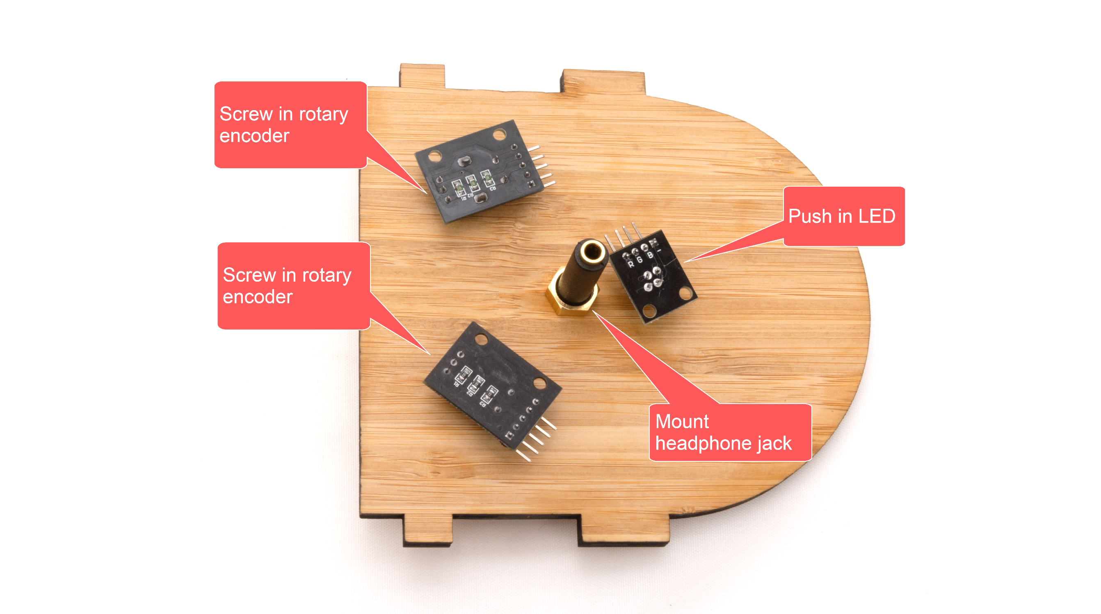

# STEP 18: Wire up front panel components

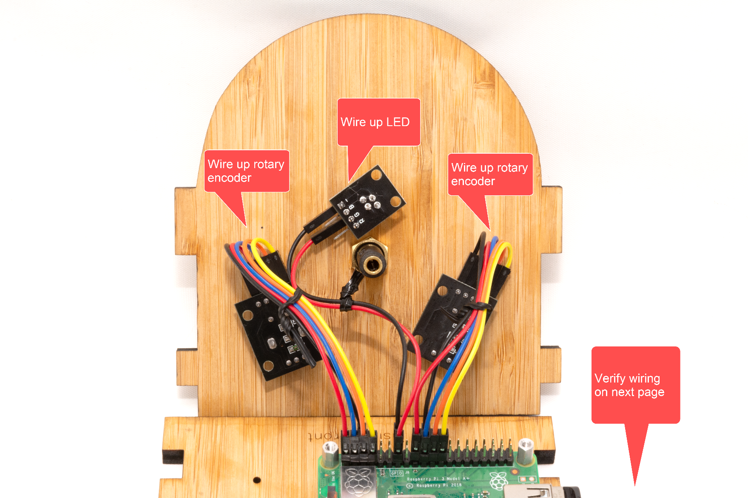

# STEP 19: Verify wiring



# STEP 20: Test it again

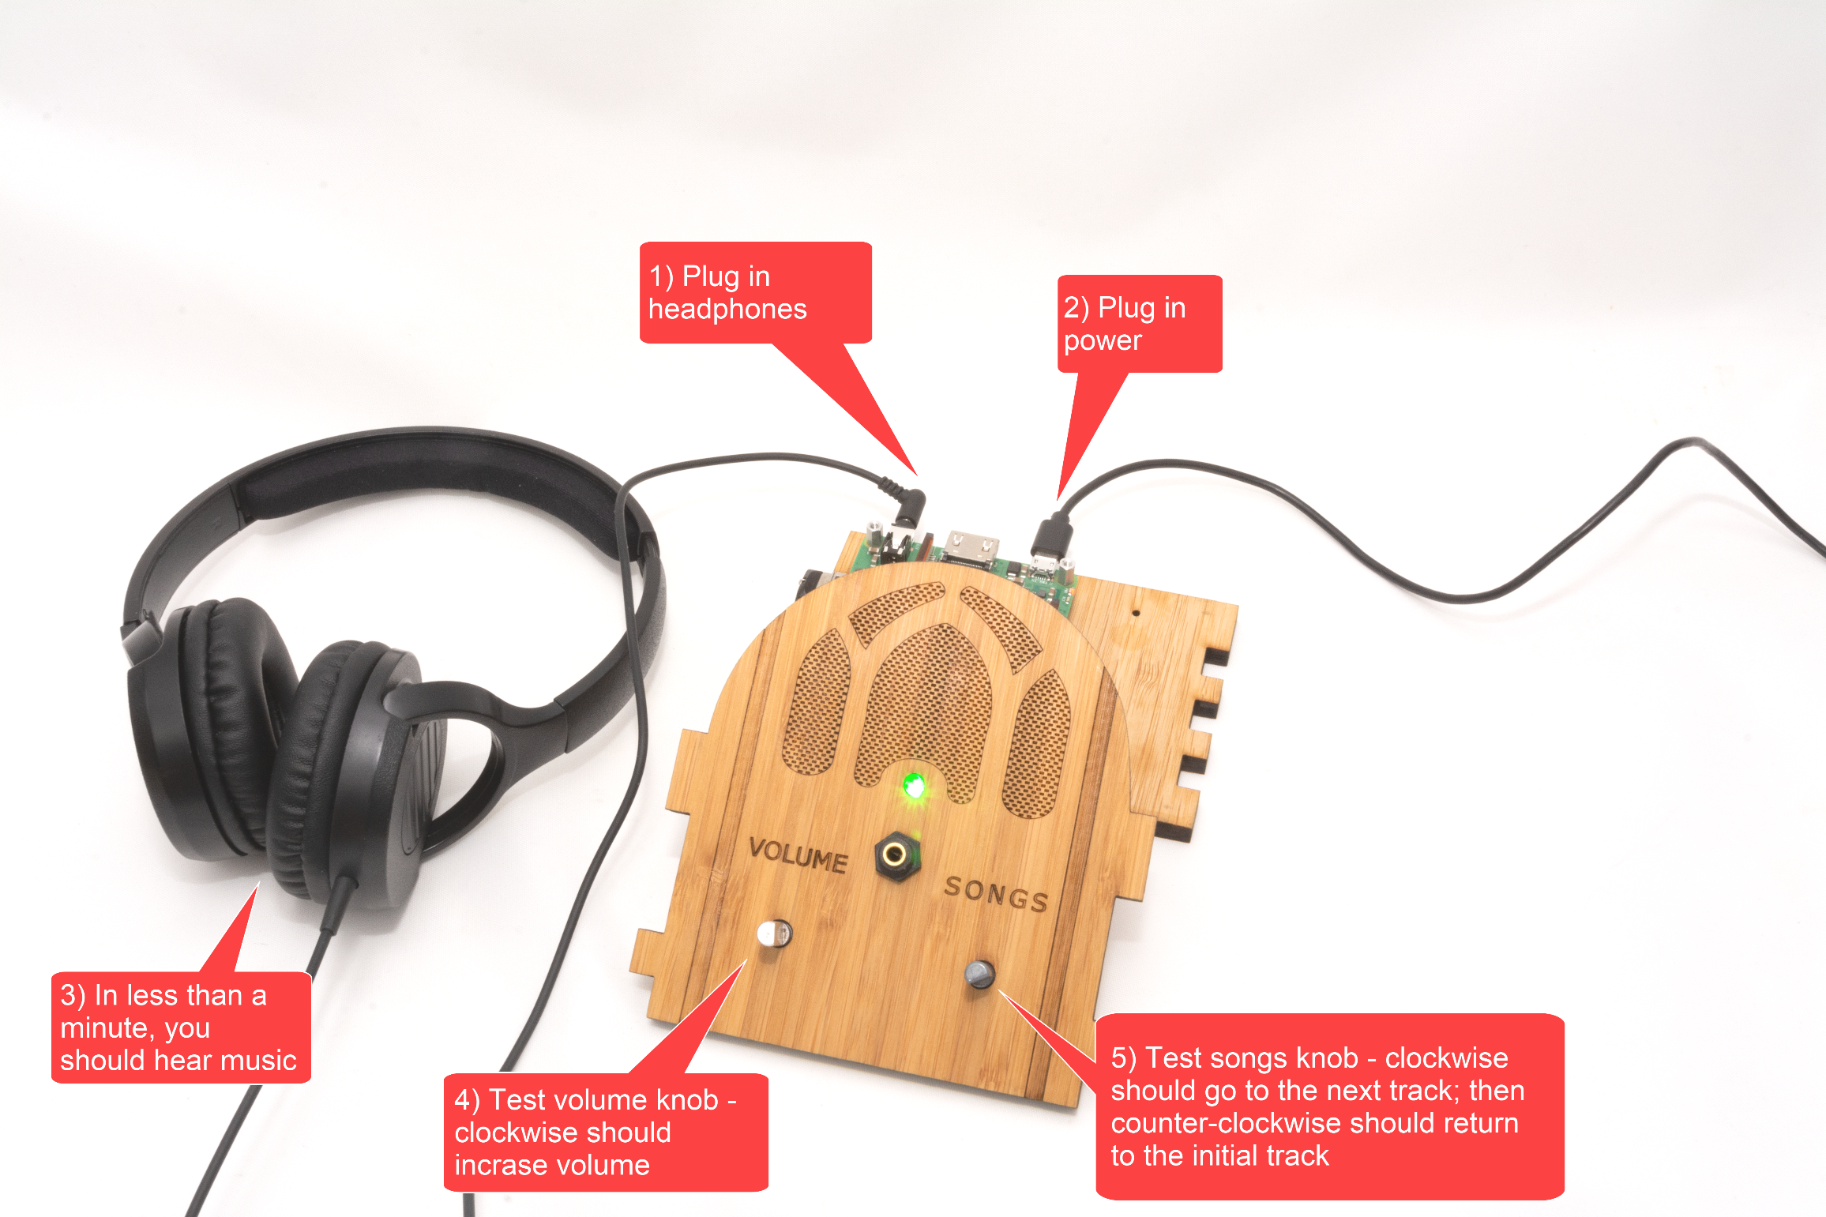

# STEP 21: Adjust the knob wiring (if necessary)

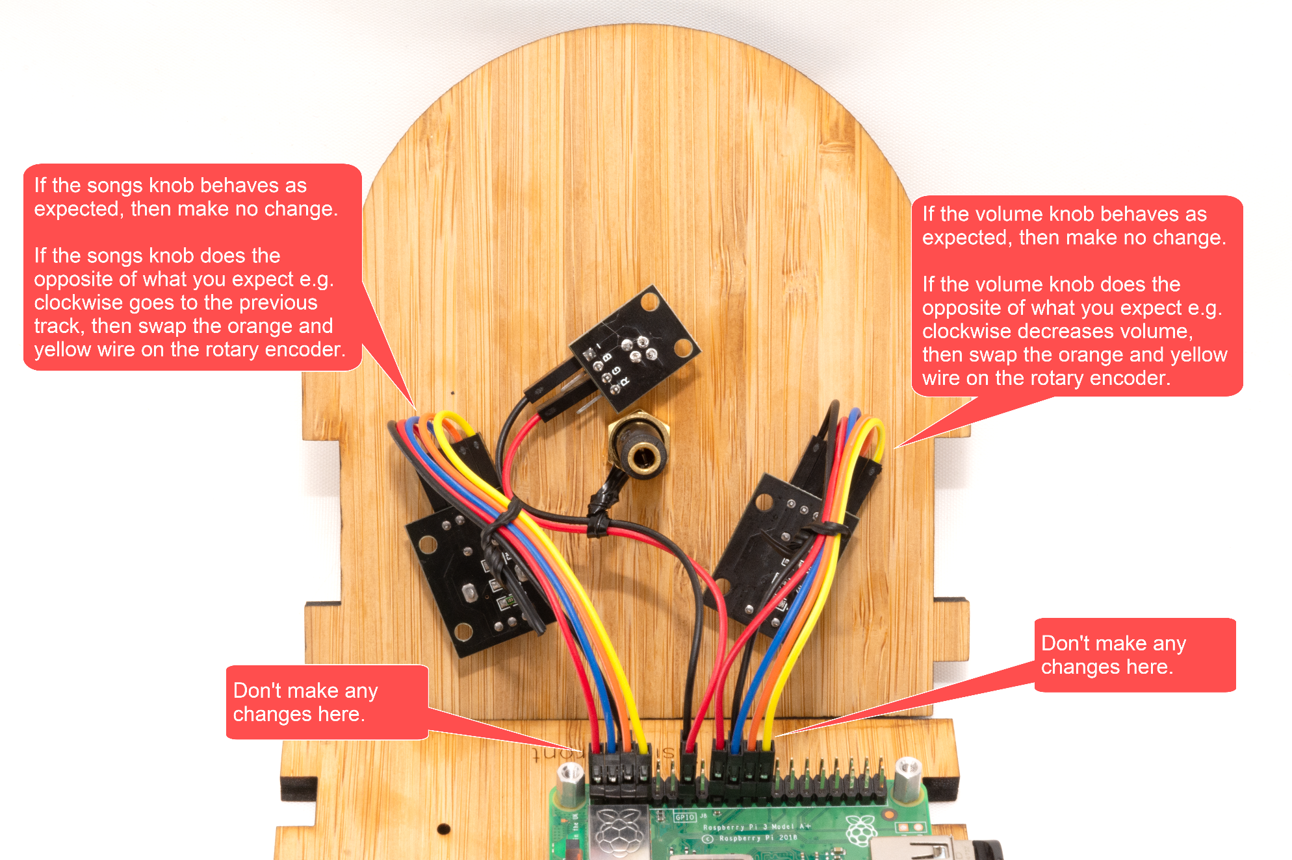

# STEP 22: Add glue

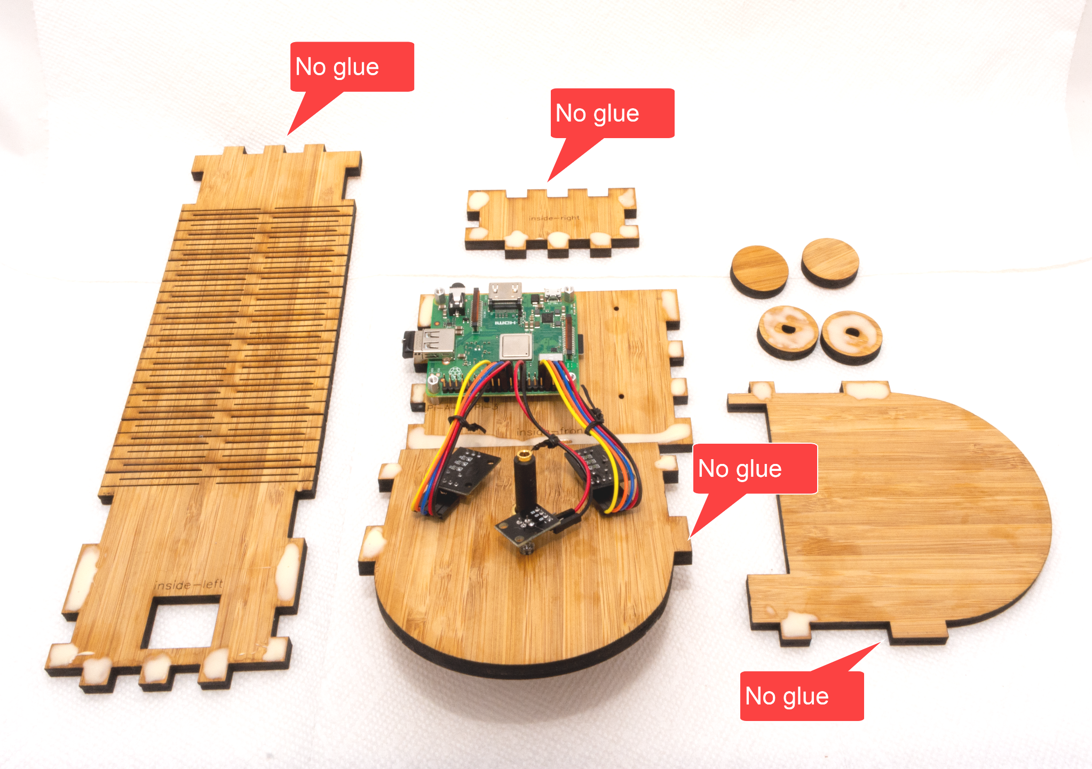

# STEP 23: Add audio cable

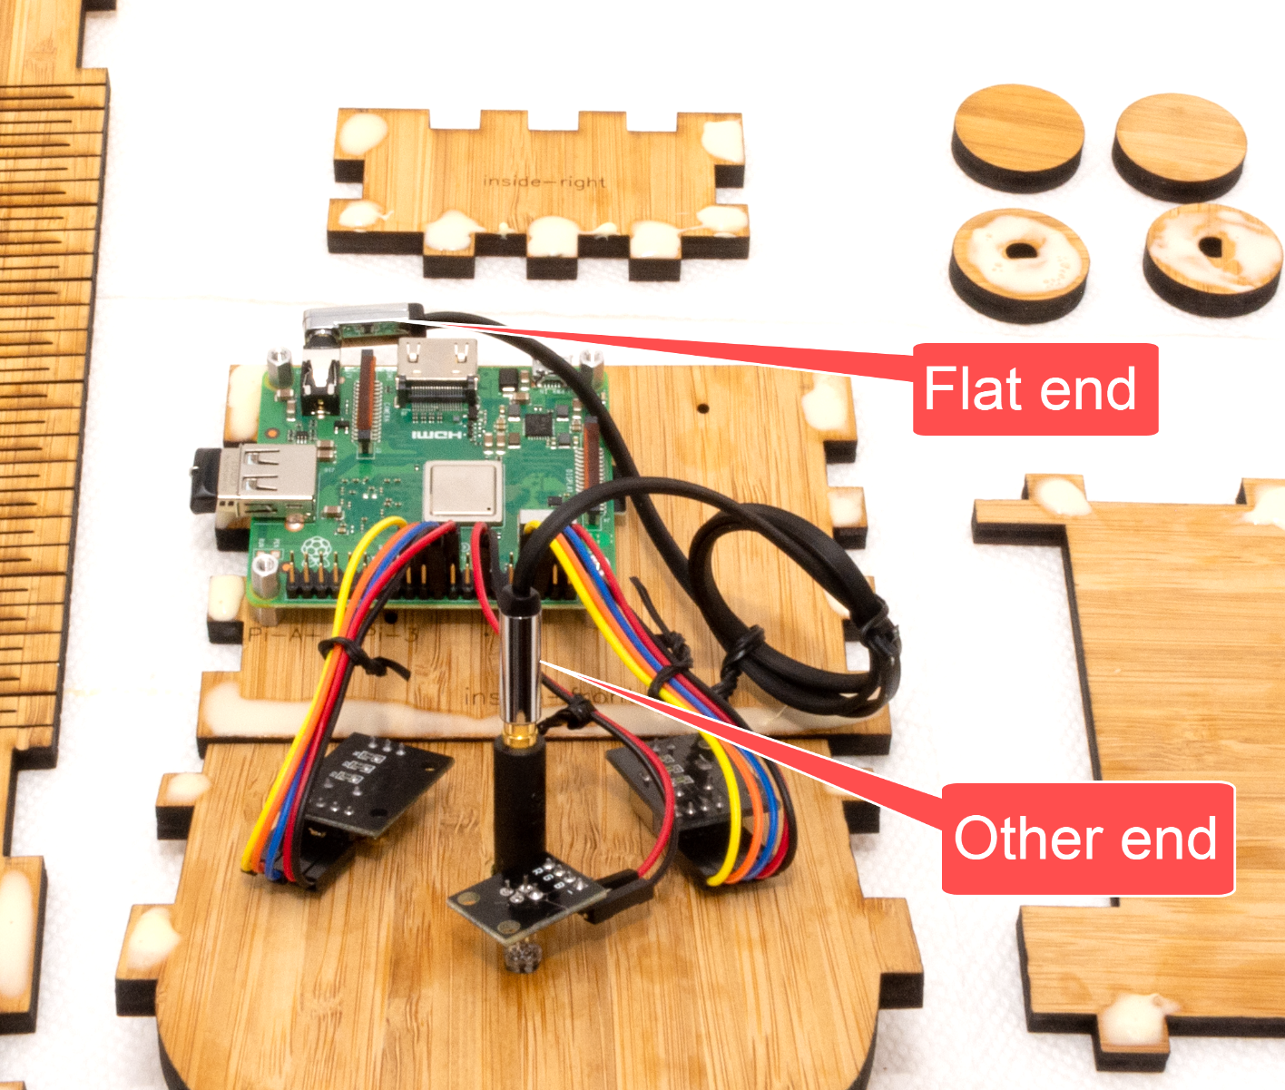

# STEP 24: Glue it

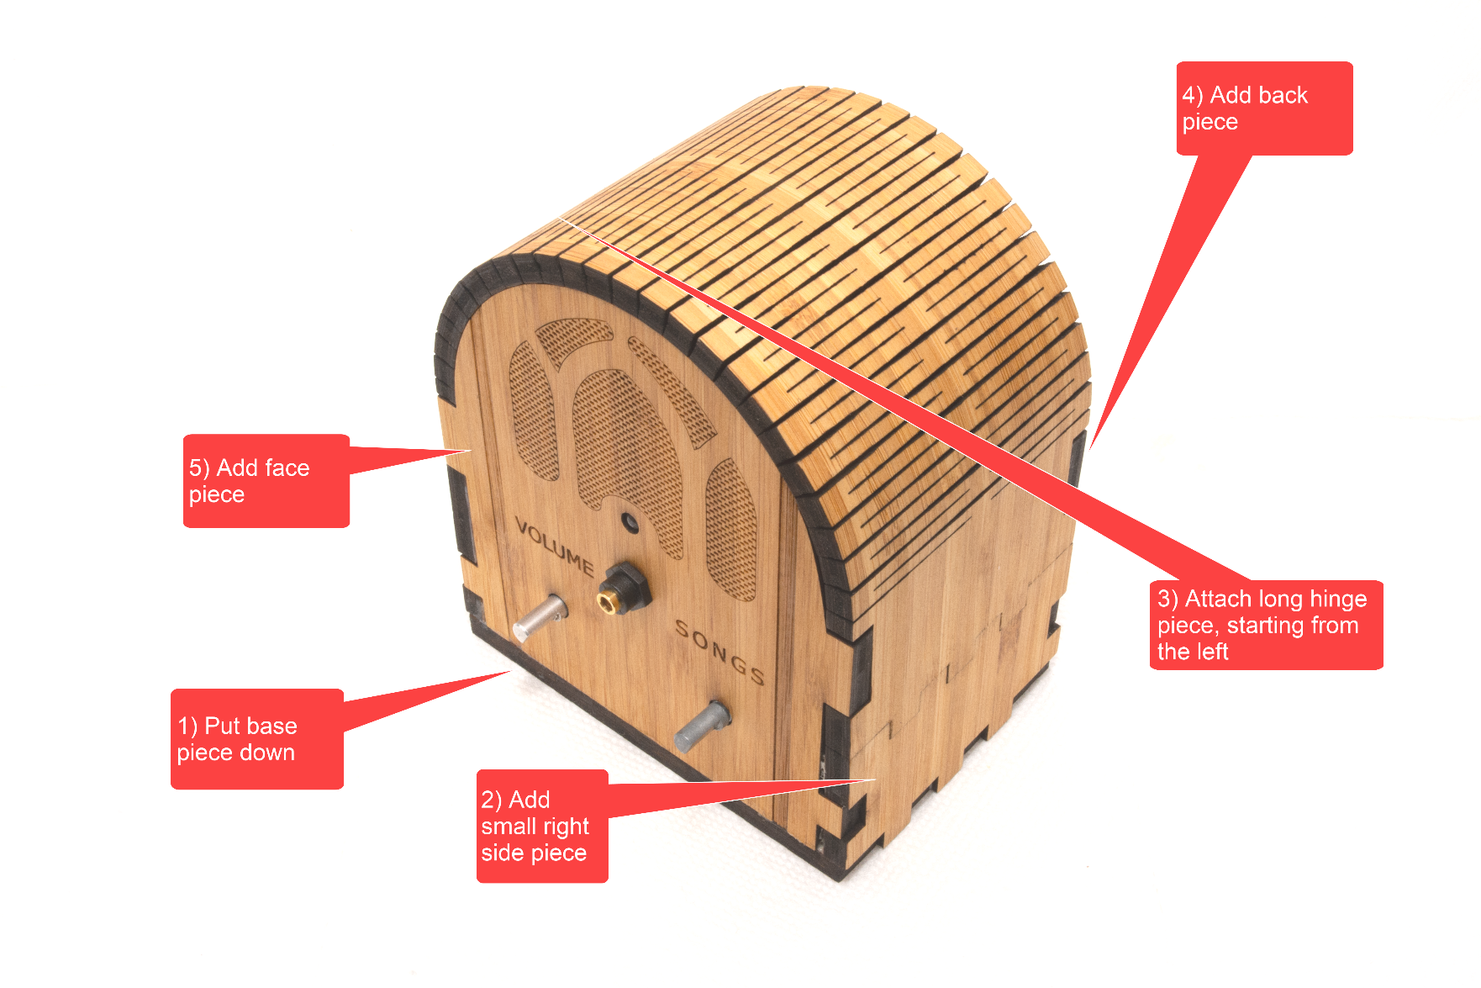

# STEP 25: Sand the clasp (if necessary)

If the clasp won’t close i.e. is too tight, then very lightly sand as per below. You can also do this after you have clamped & glued. So if your glue is starting to set as you read this, skip to the next step. Then return here after you take the clamp/tape off.

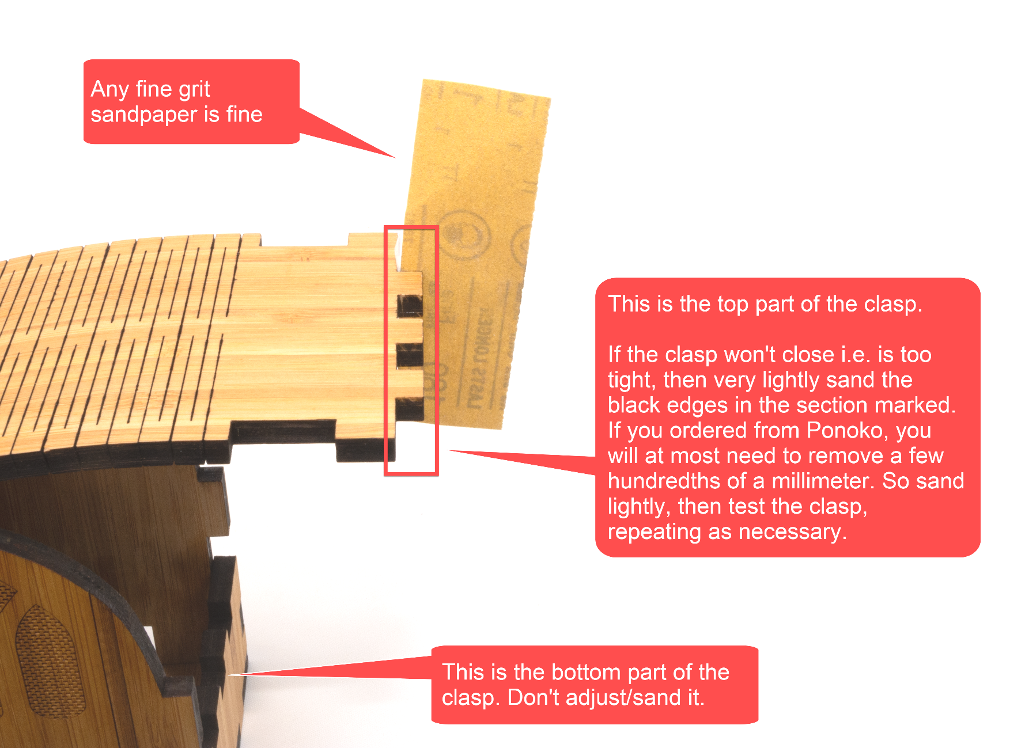

# STEP 26: Clamp it

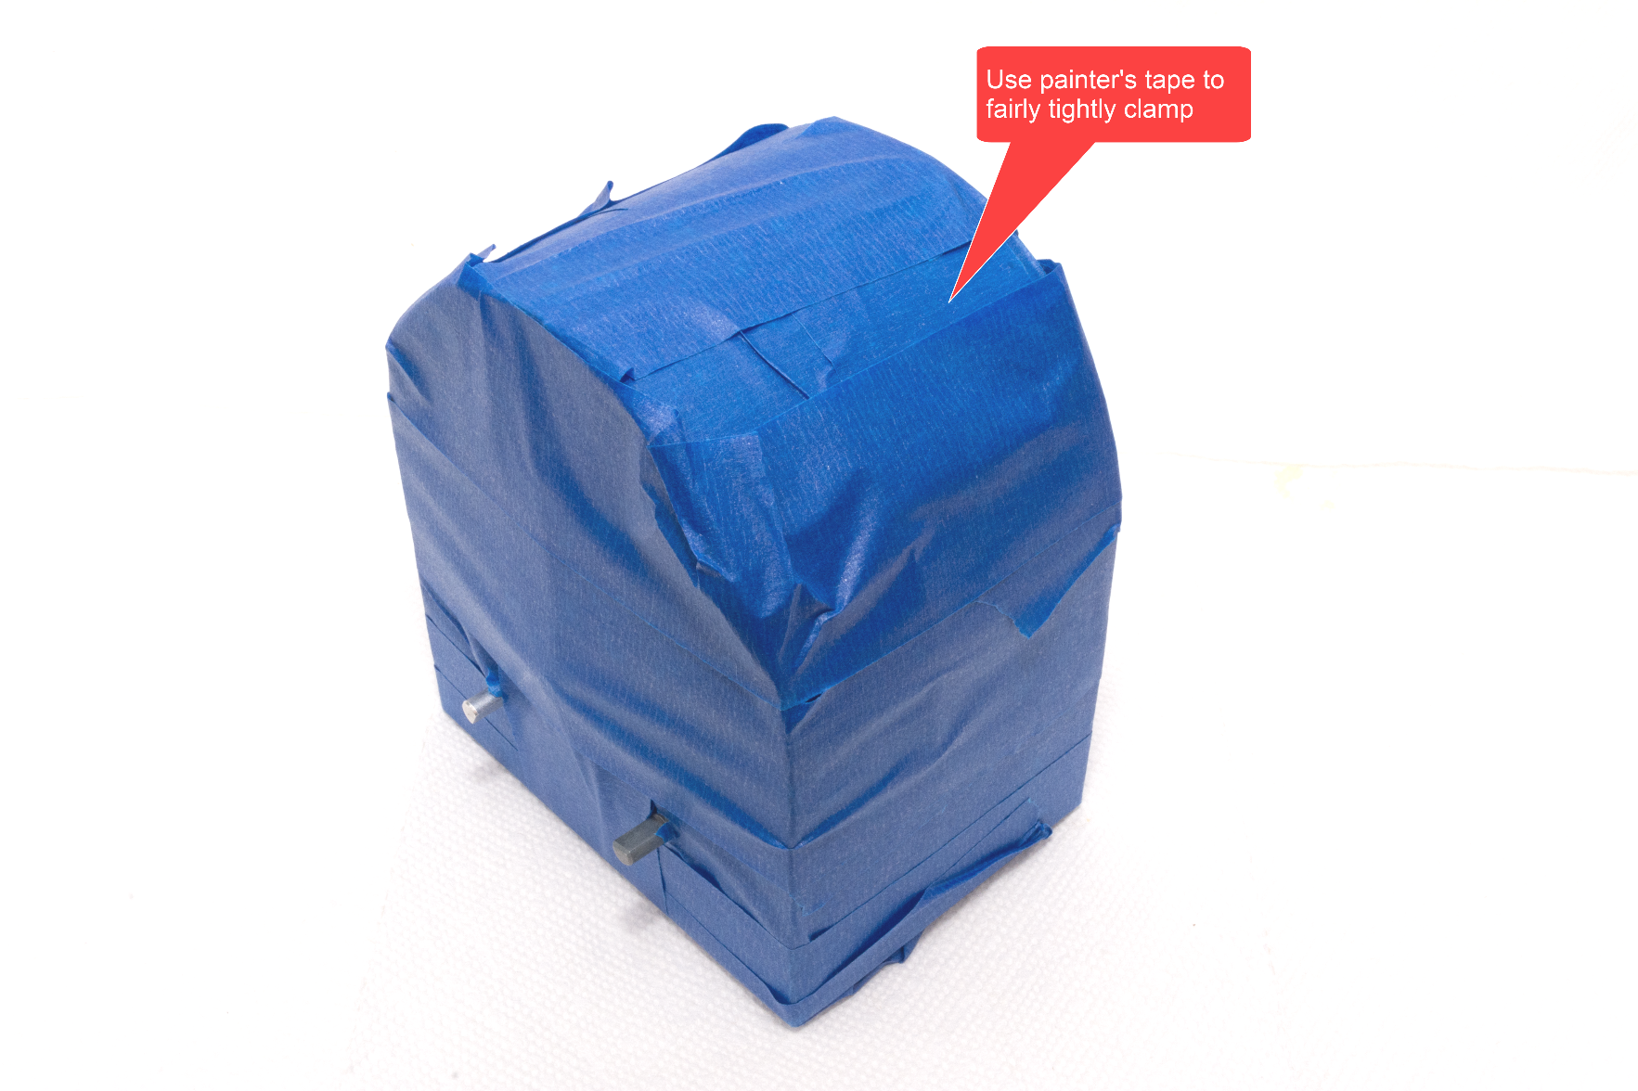

# STEP 27: Glue the knobs

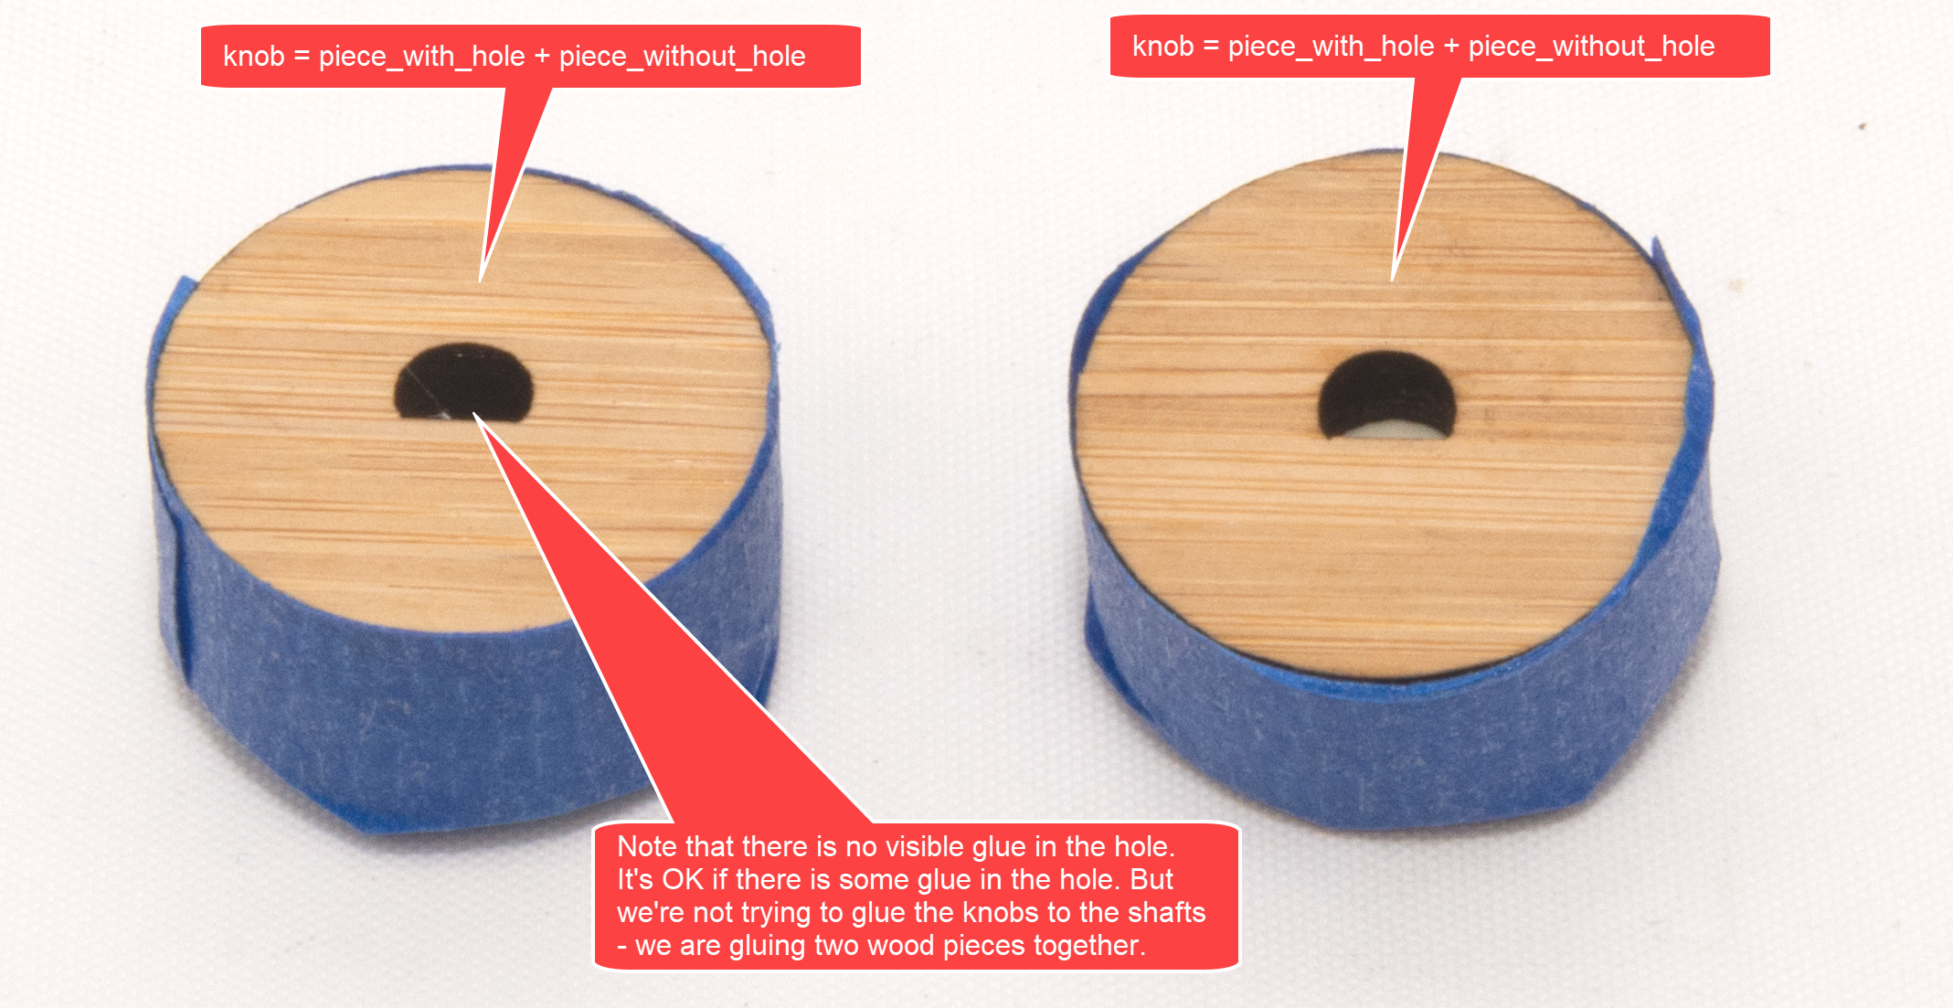

# STEP 28: Place knobs on shafts

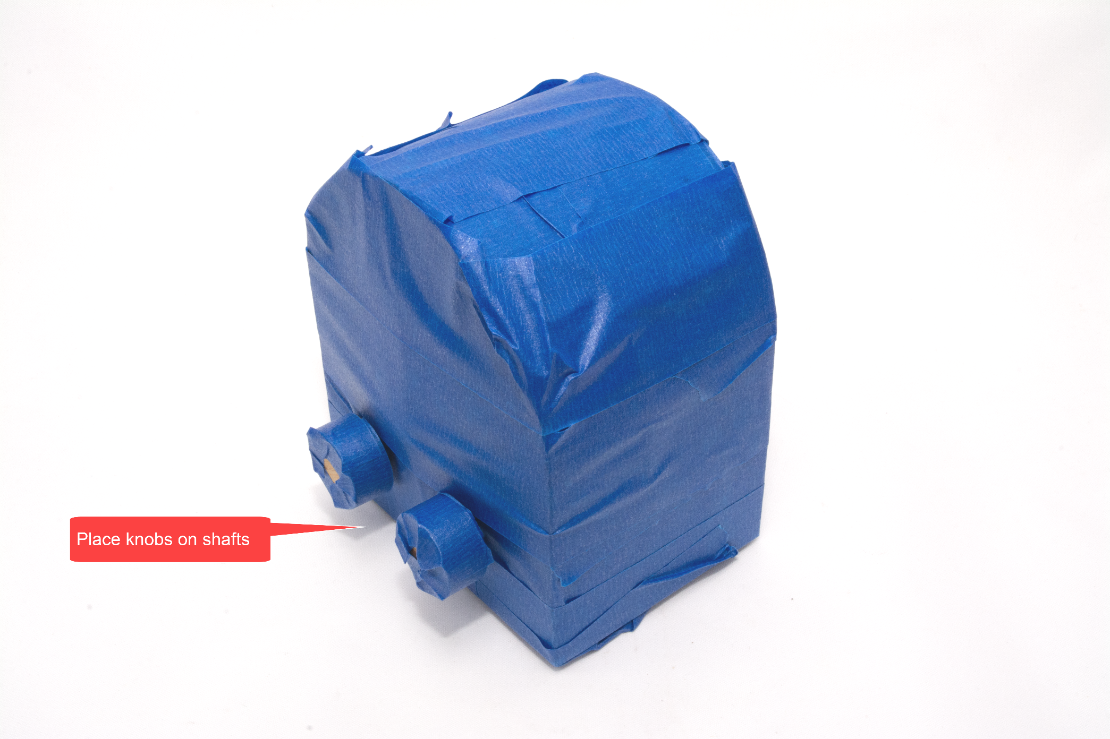

# STEP 29: Let the glue dry

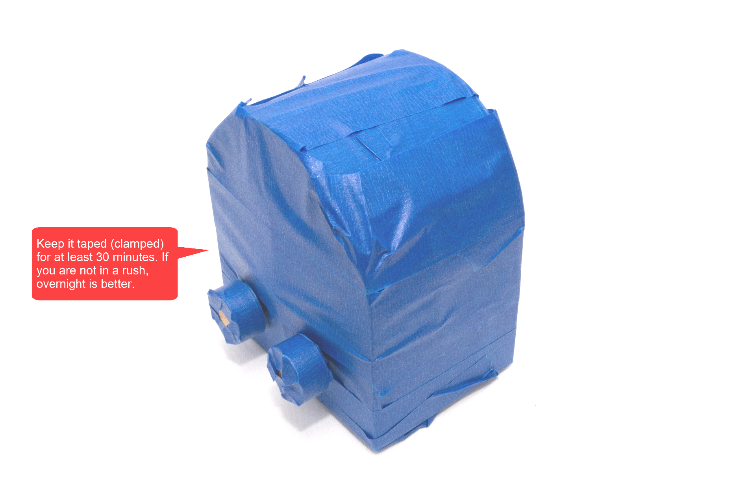

# STEP 30: Remove the tape

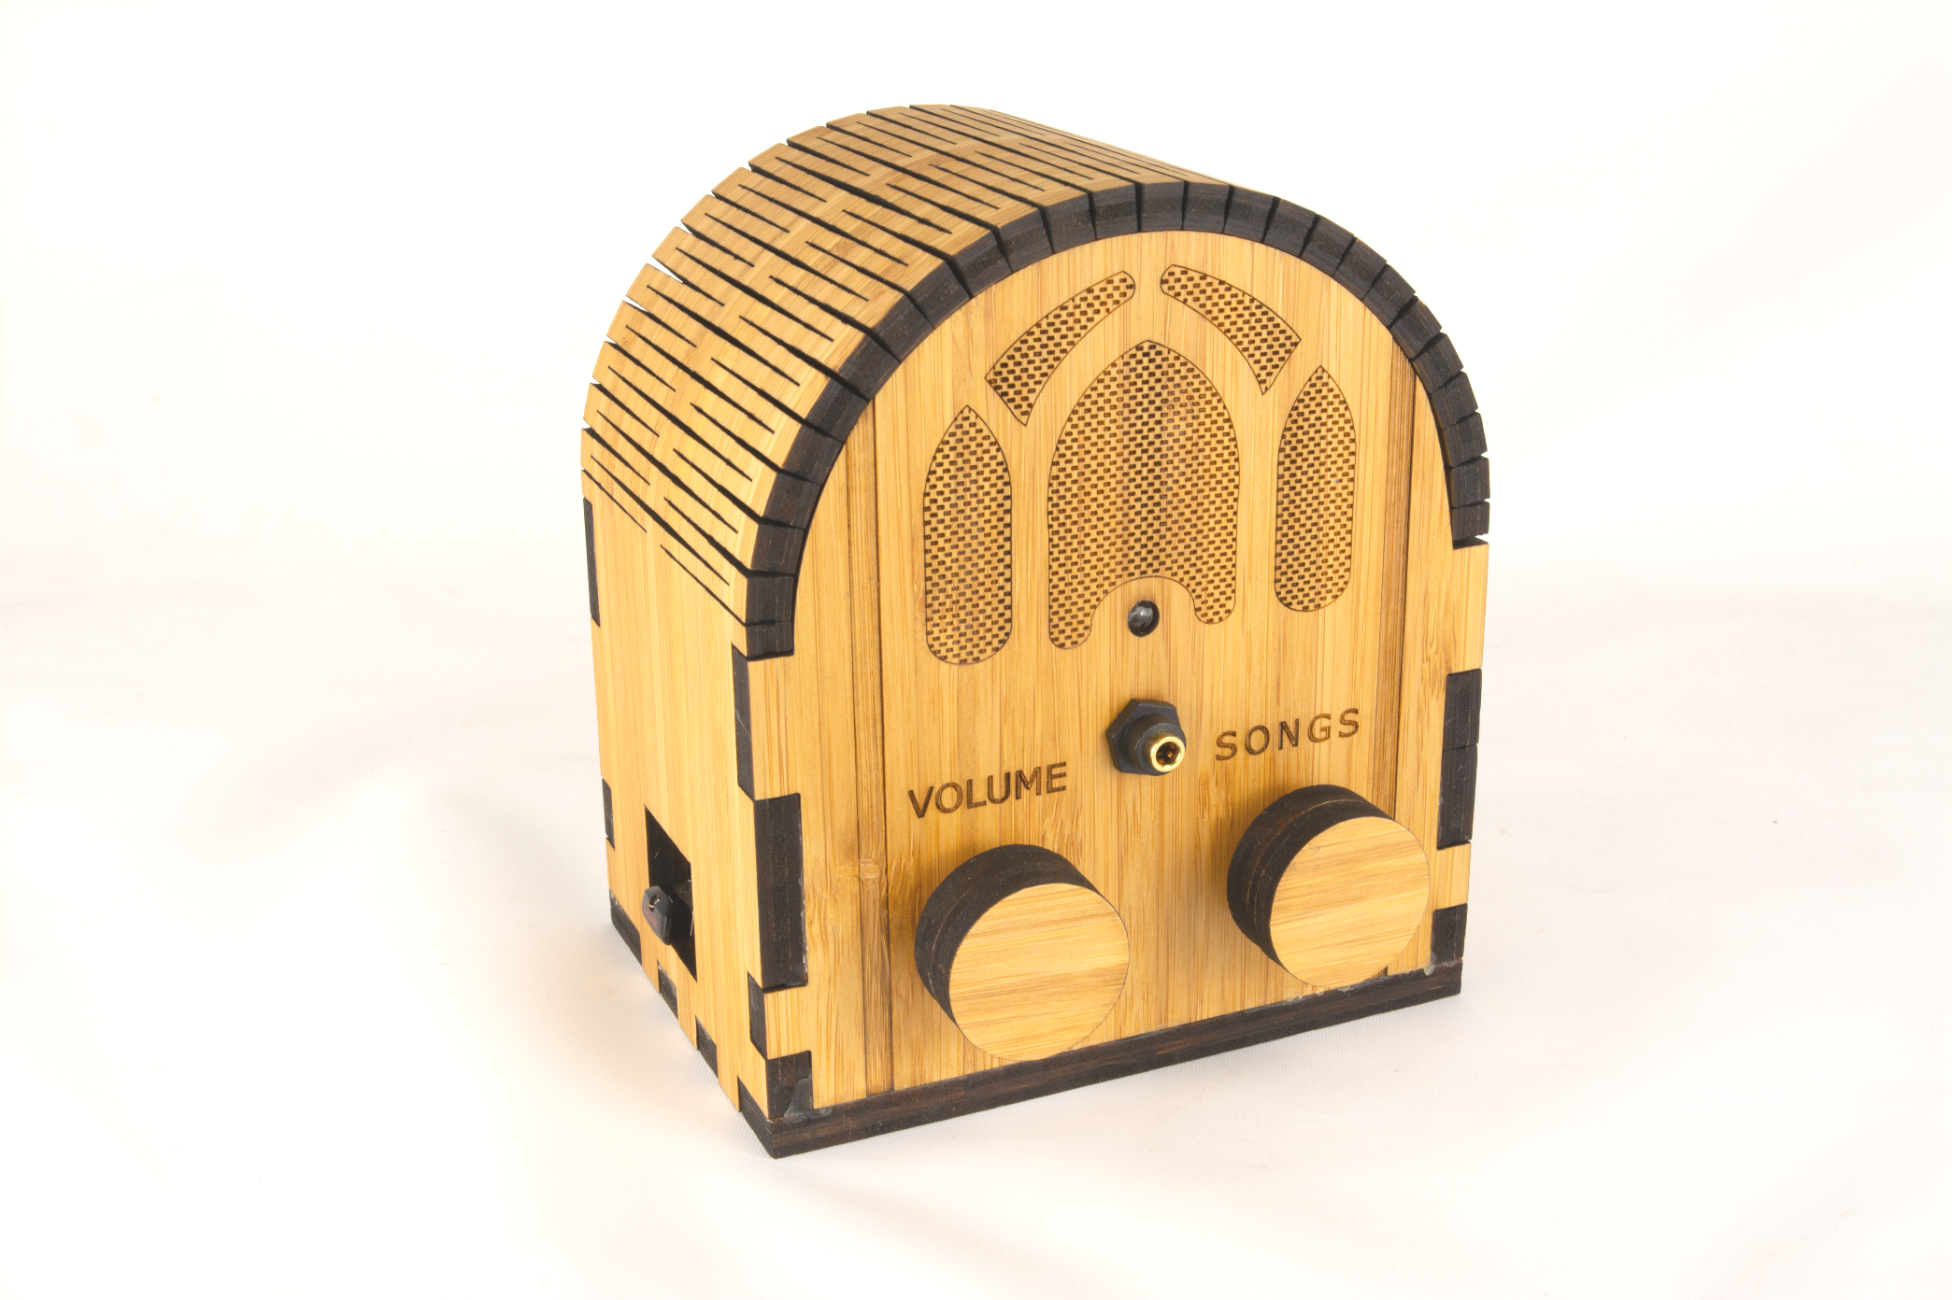

# STEP 31: Add glue to the clasp (if necessary)

If the clasp does not latch security i.e. is a bit loose, then very slightly increase the size of the tabs by applying a thin layer of glue and allowing it to dry before re-latching. If you ordered from Ponoko, it’s unlikely that you will have to do this. But if you do, then use a very thin layer of glue and perhaps only on the top of the latch. That is, if the Ponoko sizing is off, it’s only going to be off by a fraction of a millimeter.

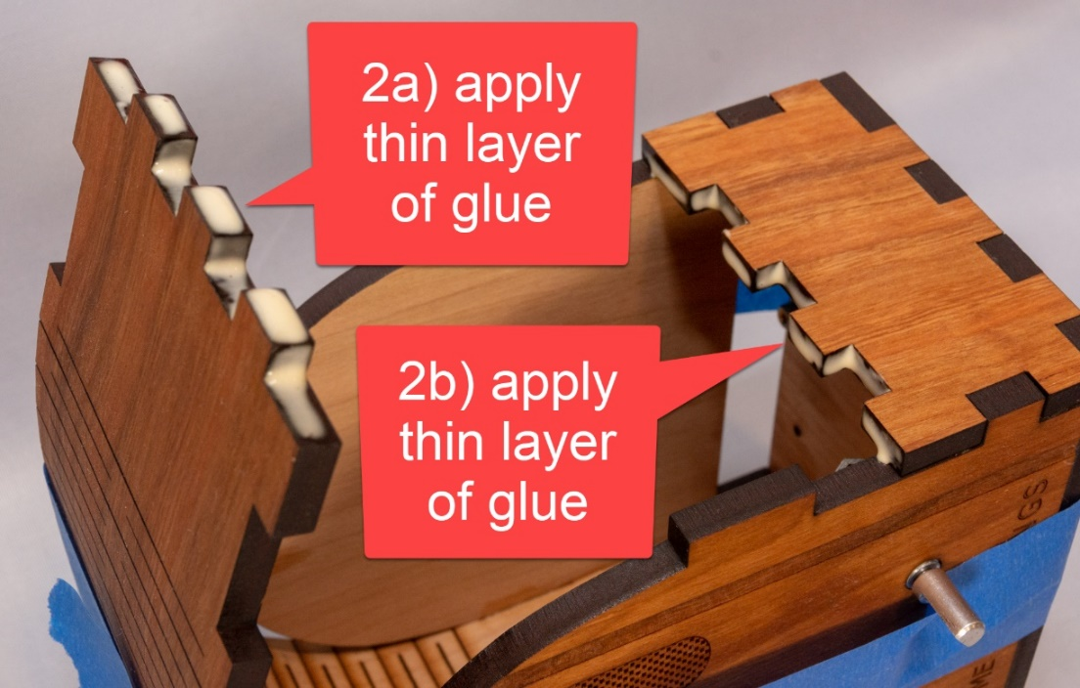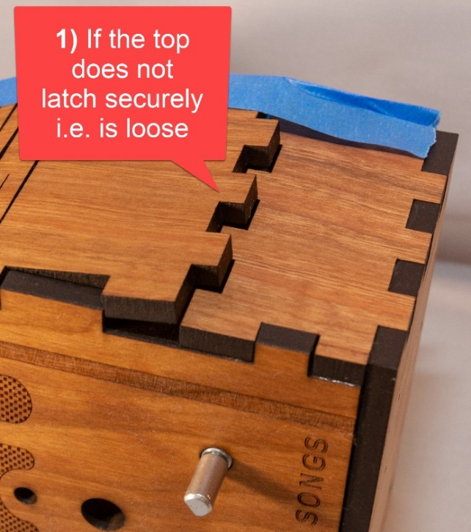



# STEP 32: Adjust the knobs (if necessary)

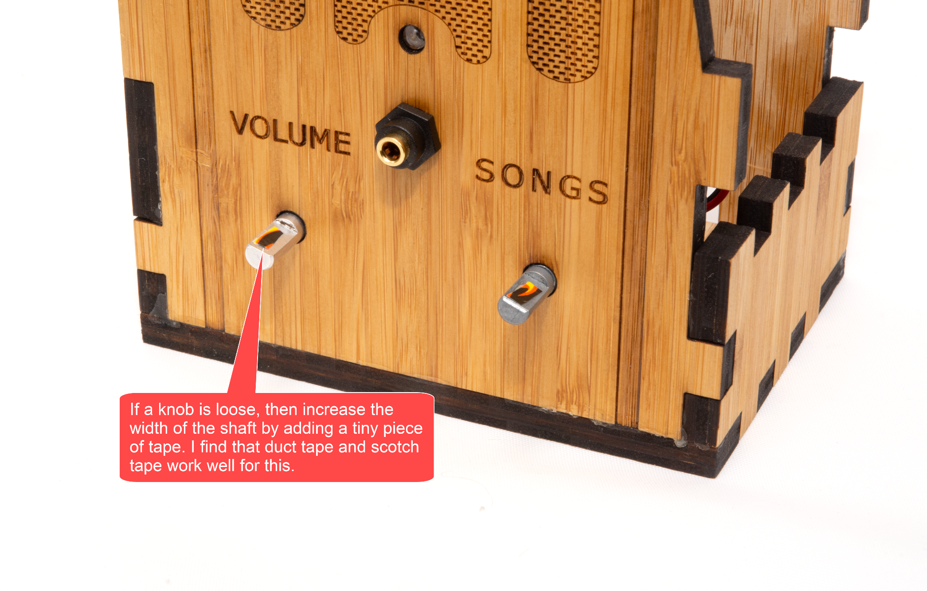

# STEP 33: Tape instructions

Print this page and tape the instructions in the box below to the bottom of your new Dementia Friendly Music Player:

|  |
| --- |
| **To create personalized music**  **Organize the music on your computer**  One folder per album. Use MP3 files, must have .mp3 file extension. Or iTunes files (.m4a). Or FLAC files (.flac). Optionally, use folder names prefixes to specify the play order e.g. A_, B_  **Copy the music to the USB thumb drive**   1. https://images-na.ssl-images-amazon.com/images/I/71cTRglrgcL._SL1500_.jpgUnplug the Dementia Friendly Music Player. 2. Remove the USB thumb drive and place in your computer. 3. Copy music files from your computer to the USB thumb drive. 4. Put the USB thumb drive back in. 5. Plug in your Dementia Friendly Music Player. |

# STEP 34: Done!

Congratulations! You should have a fully functional Dementia Friendly Music Player.

# Appendix 1: Building 10+ at a time

Assumptions:

* You want to build 10 or more units at a time.
* You are planning this far enough in advance (6 weeks or more) that you can order some of the parts directly from China.
* You will either order from Ponoko and get a quantity discount, or do your own laser cutting e.g. at a maker space – both options are costed below
* If laser cutting yourself, I’m assuming that you will use 5.2mm cherry MDF wood:
  + Looks great, is commonly available, laser cuts well
  + Does really need wood finishing e.g. linseed oil or lacquer
  + At my supplier, a 4’x8’ sheet is $55, and you can make 24 cases from it
  + Be sure to use the matching laser cutting file from [github](https://github.com/rosswesleyporter/dqmusicbox/tree/master/case/laser_cut/wood_headphones_only)
  + Costs will vary, for each unit - I assume: $5.50 in wood, 15 minutes of laser time @ $1/min, $1 for wood finishing product
  + At my maker space, I can make a case for ~$19, but for safety the estimate below is a bit higher

|  |  |  |  |  |  |  |
| --- | --- | --- | --- | --- | --- | --- |
| # units to make | 10 |  |  |  |  |  |
|  |  |  |  |  |  |  |
| **Item** | **Supplier** | **Quan** | **Each** | **Total** | **Per unit** | **Notes** |
| Wood case | Maker space | 10 | $21.50 | $215.00 | $21.50 | Or order 10+ from Ponoko for @$31.01 |
| [Raspberry Pi 1 A+ single board computer](http://www.newark.com/raspberry-pi/raspbrry-moda-512m/silicon-manufacturer-broadcom/dp/81Y5333) | Newark | 10 | $20.00 | $200.00 | $20.00 |  |
| [Power supply](http://www.mcmelectronics.com/product/28-19338) | Newark | 10 | $4.99 | $49.90 | $4.99 |  |
| [Panel mount 3.5mm headphone jack](http://www.newark.com/mcm/27-5937/3-5mm-inline-stereo-mount-female/dp/40T6284) | Newark | 10 | $2.69 | $26.90 | $2.69 |  |
| [Female-female jumper wires](https://www.aliexpress.com/item/32800215149.html?spm=a2g0s.9042311.0.0.6b164c4d50jzDO) | Ali Express | 10 | $0.60 | $6.00 | $0.60 |  |
| [M2.5 4mm thread + 6mm standoff screws (30 pieces)](https://www.aliexpress.com/item/32978007708.html?spm=a2g0s.9042311.0.0.6b164c4d50jzDO) | Ali Express | 3 | $4.99 | $14.97 | $1.50 |  |
| [Audio cable](https://www.aliexpress.com/item/32828101917.html?spm=a2g0s.9042311.0.0.6b164c4d50jzDO) | Ali Express | 10 | $2.45 | $24.50 | $2.45 |  |
| [KY-016 indicator LED (10 pieces)](https://www.aliexpress.com/item/32955003054.html?spm=a2g0s.9042311.0.0.6b164c4d50jzDO) | Ali Express | 1 | $1.92 | $1.92 | $0.19 |  |
| [KY-040 rotary encoders (knobs) (5 pieces)](https://www.aliexpress.com/item/33004406785.html?spm=a2g0s.9042311.0.0.6b164c4d50jzDO) | Ali Express | 4 | $2.11 | $8.44 | $0.84 |  |
| [16GB micro SD card](https://www.amazon.com/Kingston-16GB-microSDHC-Adapter-SDCS2/dp/B07YGZHSJS/ref=dp_ob_title_ce?th=1) | Amazon | 10 | $4.75 | $47.50 | $4.75 |  |
| [USB thumb drive](https://www.amazon.com/SanDisk-16GB-Cruzer-Flash-Drive/dp/B07MDXBT87/ref=sr_1_10?keywords=Cruzer+8GB&qid=1572121525&s=electronics&sr=1-10) | Amazon | 10 | $5.60 | $56.00 | $5.60 |  |
|  |  |  |  |  | **$65.11** | + tax + shipping |

# Appendix 2: Change log

|  |  |
| --- | --- |
| v1, November 2015 | Original release |
| v2, September 2016 | * Changed music storage from a micro-SD memory card to a conventional USB memory stick. * Changed the base Operating System from full Raspbian to [DietPi](http://dietpi.com/) – much smaller, so faster to boot, and less to go wrong. |
| v3, January 2017 | * Changed from USB audio to Pi built-in audio, including a firmware update for excellent audio quality. |
| v4, May 2017 | * Switched to bamboo for durability and use of standoffs. * Switched to Pi A+ to lower cost. * Made USB thumb drive externally accessible, to make it easier for the caregiver to organize music. |
| v4.01, 25 June 2017 | * Minor edits. |
| v4.01_1, 20 July 2017 | * Minor edits. |
| v4.01_2, 11 August 2017 | * Added links for ordering parts in the UK. * Added detailed instructions for write protecting a micro-SD card. |
| v4.01_3, 12 August 2017 | * Minor edits |
| v4.01_4, 12 August 2017 | * Minor edits |
| v4.01_5, 14 October 2017 | * Edited text and updated photographs to reflect the change from an HDD-style LED to a KY-016 LED module. |
| v4.01_6, 26 February 2018 | * Updated the links for purchasing the parts. No changes to the parts themselves, just the links. * Minor change to the instructions, noting how the build can be accomplished in one sitting, if desired. |
| v4.1, 7 April 2018 | * Reflects that the software has been updated to support the new Raspberry Pi 3 B+. No new software features. |
| v4.1_1, 23 April 2018 | * Updated to reflect the new bamboo case design. |
| v4.1_2, 22 July 2018 | * Updated for the new cherry wood version |
| 27 Jan 2019 | * Updated to note support for the Raspberry Pi 3A+. |
| v4.2, 1 March 2019 | * Switched to pmount for USB drive auto mounting. |
| v4.2, 7 April 2018 | * Removed instructions for write protecting the SD card – rarely used and may cause certain rare problems |
| v4.2, 26 October 2019 | * Updated the parts list * Updated Ponoko instructions |
| v4.2, 28 October 2019 | * Updated Ponoko instructions |
| v4.2.1, 30 October 2019 | * Changed link to the new v4.2.1 of the software image * Noted support for Pi 4 * Updated Ponoko instructions to match Ponoko’s updated user interface |
| v4.2.1, 19 December 2019 | * Minor update – naming conventions |
| v4.2.1, 22 December 2019 | * Updated to reflect the change from cherry to bamboo e.g. updated almost all of the photos. * Added new steps to the instructions, particularly mid-point tests and troubleshooting. |
| v4.2.1, 14 March 2020 | * Added costing for those that want to make 10+ units at a time |